**Test cases**

# 1) View Pages (Non-user)

|  |  |  |  |  |  |  |
| --- | --- | --- | --- | --- | --- | --- |
| **Test No.** | **Test Case** | **Test Description** | **Expected** | **Outcome** | **Recommendations** | **Ref** |
| **1.1** | **Load up the welcome page** |  |  |  |  |  |
| 1.1.1 |  | Load on a desktop site:  **Data**  Pixel-width: 1920px | Jumbotron displays fully with image,  Featured posts columns = 2 with images,  Latest posts take up 1 row each | As expected |  |  |
| 1.1.2 |  | Load on a tablet device  **Data**  Pixel-width: 1024px | Jumbotron displays fully with image,  Featured posts columns = 2 no images,  Latest posts take up 1 row each | As expected |  |  |
| 1.1.3 |  | Load on a mobile device  **Data**  Pixel-width: 375px | Jumbotron is removed,  Featured posts rows = 2,  Latest posts take up 1 row each | As expected – see recommendations | Sizing of the jumbotron text needs to be reduced |  |
| **1.2** | **Load up review archive** |  |  |  |  |  |
| 1.2.1 |  | Load on a desktop site:  **Data**  Pixel-width: 1920px | Filters stretch across 80% of the site,  Individual posts display all information,  Columns = 3. | As Expected |  |  |
| 1.2.2 |  | Load on a tablet device  **Data**  Pixel-width: 1024px | Filters stretch across 90% of the site,  Individual posts display most information, | As expected |  |  |
| 1.2.3 |  | Load on a mobile device  **Data**  Pixel-width: 375px | Filters are hidden in dropdown,  Individual posts are shown in card form, with limited information | As expected |  |  |
| **1.3** | **Load up blog archive** |  |  |  |  |  |
| 1.3.1 |  | Load on a desktop site:  **Data**  Pixel-width: 1920px | Filters stretch across 80% of the site,  Individual posts display all information, | As expected |  |  |
| 1.3.2 |  | Load on a tablet device  **Data**  Pixel-width: 1024px | Filters stretch across 90% of the site,  Individual posts display most information, | As expected |  |  |
| 1.3.3 |  | Load on a mobile device  **Data**  Pixel-width: 375px | Filters are hidden in dropdown,  Individual posts are shown in card form, with limited information | As Expected – see recommendations | Comments, likes, and read more button, could be smaller |  |
| 1.4 | **Load up news archive** |  |  |  |  |  |
| 1.4.1 |  | Load on a desktop site:  **Data**  Pixel-width: 1920px | Date filters are shown as a sidebar,  Individual posts display all information and almost all content with the main body truncated, | As Expected |  |  |
| 1.4.2 |  | Load on a tablet device  **Data**  Pixel-width: 1024px | Date filters are shown as a sidebar,  Individual posts display most information and almost all content with the main body truncated, | As Expected |  |  |
| 1.4.3 |  | Load on a mobile device  **Data**  Pixel-width: 375px | Date filters are hidden,  Individual posts are shown in card form, with limited information | As Expected – see recommendations | Main content of news article could be truncated more |  |
| 1.5 | **Load up login/register page** |  |  |  |  |  |
| 1.5.1 |  | Load on a desktop site:  **Data**  Pixel-width: 1920px | Form displayed with a max-width of 280px | As Expected |  |  |
| 1.5.2 |  | Load on a tablet device  **Data**  Pixel-width: 1024px | Form displayed with a max-width of 280px | As Expected |  |  |
| 1.5.3 |  | Load on a mobile device  **Data**  Pixel-width: 375px | Form displayed with a max-width of 200px | As Expected |  |  |
| 1.5.4 |  | Load page as a logged in user  **Data**  User: user1@ltc.co.uk | The form is not displayed.  User is redirected to home. | As expected. |  |  |
| 1.5.5 |  | Load page as a logged in staff member  **Data**  User: admin@ltc.co.uk | The form is not displayed.  User is redirected to Dashboard. | As expected. |  |  |
| 1.6 | **NAVBAR** |  |  |  |  |  |
| 1.6.1 |  | Load on a desktop site:  **Data**  Pixel-width: 1920px | The primary navbar displays the logo centrally and links to:   * Reviews * Blog * News * Contact * Search bar   The secondary navbar displays:   * Login navigation * Account access * Dashboard access | As expected. |  |  |
| 1.6.2 |  | Load on a tablet device  **Data**  Pixel-width: 1024px | Same as above.  The width of both navigation bars are made 100% | As expected. |  |  |
| 1.6.3 |  | Load on a mobile device  **Data**  Pixel-width: 375px | Same as above.  The logo size is reduced to a max height of 40px.  Both Menus are reduced to hamburgers | Not as expected,  Navigation is not hidden in hamburgers. |  |  |

# 2) View Dashboard-Pages

|  |  |  |  |  |  |  |
| --- | --- | --- | --- | --- | --- | --- |
| **Test No.** | **Test Case** | **Test Description** | **Expected** | **Outcome** | **Recommendations** | **Ref** |
| **2.1** | **Load up the Dashboard** |  |  |  |  |  |
| 2.1.1 |  | Load up as a basic user.  **Data**  User: [user@ltc.co.uk](mailto:user@ltc.co.uk)  Roles: User | User has limited functions available through their dashboard. These are:   * Edit Account * Notifications | As expected |  |  |
| 2.1.2 |  | Load up as an author.  **Data**  User: [author@ltc.co.uk](mailto:author@ltc.co.uk)  Roles: User, Author | Should have access to user dashboard and:   * Published Posts * Pending Posts * Draft Posts * Create Post | As expected |  |  |
| 2.1.3 |  | Load up as an editor.  **Data**  User: [editor@ltc.co.uk](mailto:editor@ltc.co.uk)  Roles: User, Editor | Should have access to user dashboard and:   * Pending Posts | As expected |  |  |
| 2.1.4 |  | Load up as a moderator.  **Data**  User: [moderator@ltc.co.uk](mailto:moderator@ltc.co.uk)  Roles: User, Moderator | Should have access to user dashboard and:   * All Cases * My Cases * Closed Cases * All Reports * Users | As expected |  |  |
| 2.1.5 |  | Load up as an administrator.  **Data**  User: [admin@ltc.co.uk](mailto:admin@ltc.co.uk)  Roles: User, Admin | Should have access to user and moderator dashboard and:   * Posts * Staff * Categories * Badges * Banned Words/Phrases | As expected |  |  |
| 2.1.6 |  | Load up as an author with editor permissions.  **Data**:  User: [author2@ltc.co.uk](mailto:author2@ltc.co.uk)  Roles: User, Author, Editor | Should have access to user, author, and editor dashboard. | As expected,  Posts are saved in one place, and not generating new dashboard items |  |  |
| 2.1.7 |  | Load up as a moderator with author permissions.  **Data**  User: [moderator2@ltc.co.uk](mailto:moderator2@ltc.co.uk)  Roles: User, Moderator, Author | Should have access to user, author, and moderator dashboard. | As expected |  |  |
| 2.1.8 |  | Load up as a moderator with editor and author permissions.  **Data**  User: [moderator2@ltc.co.uk](mailto:moderator2@ltc.co.uk)  Roles: User, Moderator, Author, Editor | Should have access to user, moderator, and author dashboard. | As expected |  |  |
| **2.2** | **Load up dashboard on different devices** |  |  |  |  |  |
| 2.2.1 |  | Load up the dashboard as an admin.  **Data**  User: [admin@ltc.co.uk](mailto:admin@ltc.co.uk)  Roles: User, Admin  Pixel-width: 1920px | Dashboard items should display at least 3 in a row and no more than 4. | As expected |  |  |
| 2.2.2 |  | Load up the dashboard as an admin.  **Data**  User: [admin@ltc.co.uk](mailto:admin@ltc.co.uk)  Roles: User, Admin  Pixel-width: 1024px | Dashboard items should display at least 2 in a row and no more than 3. | As expected |  |  |
| 2.2.3 |  | Load up the dashboard as an admin.  **Data**  User: [admin@ltc.co.uk](mailto:admin@ltc.co.uk)  Roles: User, Admin  Pixel-width: 375px | Dashboard items should display only 1 in each row. | As expected |  |  |
| **2.3** | **Access Edit Profile Page** |  |  |  |  |  |
| 2.3.1 |  | Load up as a basic user.  **Data**  User: [user@ltc.co.uk](mailto:user@ltc.co.uk)  Roles: User | User should have access to changing details:   * Password * Email * Name | Partial Fail,  Missing email and name |  |  |
| 2.3.2 |  | Load up as an author.  **Data**  User: [author@ltc.co.uk](mailto:author@ltc.co.uk)  Roles: User, Author | User should have access to changing details:   * Password * Email * Name | Partial Fail,  Missing email and name |  |  |
| 2.3.3 |  | Load up as a Moderator.  **Data**  User: [moderator@ltc.co.uk](mailto:moderator@ltc.co.uk)  Roles: User, Moderator | User should have access to changing details:   * Password * Email * Name | Partial Fail,  Missing email and name |  |  |
| 2.3.4 |  | Load up as an Admin.  **Data**  User: [admin@ltcl.co.uk](mailto:admin@ltcl.co.uk)  Roles: User, Admin | User should have access to changing details:   * Password * Email * Name | Partial Fail,  Missing email and name |  |  |
| **2.4** | **Access Notifications Page** |  |  |  |  |  |
| 2.4.1 |  | Load up as a basic user.  **Data**  User: [user@ltc.co.uk](mailto:user@ltc.co.uk)  Roles: User | A list of the users currently unread and previous notifications should appear. | As expected |  |  |
| 2.4.2 |  | Load up as an author.  **Data**  User: [author@ltc.co.uk](mailto:author@ltc.co.uk)  Roles: User, Author | A list of the users currently unread and previous notifications should appear. | As expected |  |  |
| 2.4.3 |  | Load up as a Moderator.  **Data**  User: [moderator@ltc.co.uk](mailto:moderator@ltc.co.uk)  Roles: User, Moderator | A list of the users currently unread and previous notifications should appear. | As expected |  |  |
| 2.4.4 |  | Load up as an Admin.  **Data**  User: [admin@ltcl.co.uk](mailto:admin@ltcl.co.uk)  Roles: User, Admin | A list of the users currently unread and previous notifications should appear. | As expected |  |  |
| **2.5** | **Access Published Posts page** |  |  |  |  |  |
| 2.5.1 |  | Load up as a basic user.  **Data**  User: [user@ltc.co.uk](mailto:user@ltc.co.uk)  Roles: User  URL: ~/Author/AllPublishedPosts | User should be redirected to their own dashboard. | As expected.  Unable an redirected |  |  |
| 2.5.2 |  | Load up as an author.  **Data**  User: [author@ltc.co.uk](mailto:author@ltc.co.uk)  Roles: User, Author  URL: ~/Author/AllPublishedPosts | User will be able to view all their own published posts. | As expected |  |  |
| 2.5.3 |  | Load up as a Moderator.  **Data**  User: [moderator@ltc.co.uk](mailto:moderator@ltc.co.uk)  Roles: User, Moderator  URL: ~/Author/AllPublishedPosts | User should be redirected to their own dashboard. | As expected.  Unable an redirected |  |  |
| 2.5.4 |  | Load up as an Admin.  **Data**  User: [admin@ltcl.co.uk](mailto:admin@ltcl.co.uk)  Roles: User, Admin  URL: ~/Author/AllPublishedPosts | User should be redirected to their own dashboard. | As expected.  Unable an redirected |  |  |
| 2.5.5 |  | Load up as an Editor.  **Data**  User: [editor@ltcl.co.uk](mailto:editor@ltcl.co.uk)  Roles: User, Editor  URL: ~/Author/AllPublishedPosts | User should be redirected to their own dashboard. | As expected.  Unable an redirected |  |  |
| **2.6** | **Access Pending Posts page** |  |  |  |  |  |
| 2.6.1 |  | Load up as a basic user.  **Data**  User: [user@ltc.co.uk](mailto:user@ltc.co.uk)  Roles: User  URL: ~/Author/AllPendingPosts | User should be redirected to their own dashboard. | As expected.  Unable an redirected |  |  |
| 2.6.2 |  | Load up as an author.  **Data**  User: [author@ltc.co.uk](mailto:author@ltc.co.uk)  Roles: User, Author  URL: ~/Author/ AllPendingPosts | User will be able to view all their own pending posts. | As expected.  Unable an redirected |  |  |
| 2.6.3 |  | Load up as a Moderator.  **Data**  User: [moderator@ltc.co.uk](mailto:moderator@ltc.co.uk)  Roles: User, Moderator  URL: ~/Author/ AllPendingPosts | User should be redirected to their own dashboard. | As expected.  Unable an redirected |  |  |
| 2.6.4 |  | Load up as an Admin.  **Data**  User: [admin@ltcl.co.uk](mailto:admin@ltcl.co.uk)  Roles: User, Admin  URL: ~/Author/ AllPendingPosts | User should be redirected to their own dashboard. | As expected.  Unable an redirected |  |  |
| 2.6.5 |  | Load up as an Editor.  **Data**  User: [editor@ltcl.co.uk](mailto:editor@ltcl.co.uk)  Roles: User, Editor  URL: ~/Author/AllPublishedPosts | User should be able to view all pending posts for editing and publishing. | As expected. |  |  |
| **2.7** | **Access Draft Posts page** |  |  |  |  |  |
| 2.7.1 |  | Load up as a basic user.  **Data**  User: [user@ltc.co.uk](mailto:user@ltc.co.uk)  Roles: User  URL: ~/Author/AllDraftPosts | User should be redirected to their own dashboard. | As expected.  Unable an redirected |  |  |
| 2.7.2 |  | Load up as an author.  **Data**  User: [author@ltc.co.uk](mailto:author@ltc.co.uk)  Roles: User, Author  URL: ~/Author/ AllDraftPosts | User will be able to view all their own draft posts. | As expected |  |  |
| 2.7.3 |  | Load up as a Moderator.  **Data**  User: [moderator@ltc.co.uk](mailto:moderator@ltc.co.uk)  Roles: User, Moderator  URL: ~/Author/ AllDraftPosts | User should be redirected to their own dashboard. | As expected.  Unable an redirected |  |  |
| 2.7.4 |  | Load up as an Admin.  **Data**  User: [admin@ltcl.co.uk](mailto:admin@ltcl.co.uk)  Roles: User, Admin  URL: ~/Author/ AllDraftPosts | User should be redirected to their own dashboard. | As expected.  Unable an redirected |  |  |
| 2.7.5 |  | Load up as an Editor.  **Data**  User: [editor@ltcl.co.uk](mailto:editor@ltcl.co.uk)  Roles: User, Editor  URL: ~/Author/AllPublishedPosts | User should be taken to pending posts they have accepting for editing. | As expected |  |  |
| **2.8** | **Access New Posts page** |  |  |  |  |  |
| **2.8.1** | **CREATE REVIEW** |  |  |  |  |  |
| 2.8.1.1 |  | Load up as a basic user.  **Data**  User: [user@ltc.co.uk](mailto:user@ltc.co.uk)  Roles: User  URL: ~/Author/CreateReview | User should be redirected to their own dashboard. | As expected |  |  |
| 2.8.1.2 |  | Load up as an author with reviewer rights.  **Data**  User: [reviewer@ltc.co.uk](mailto:reviewer@ltc.co.uk)  Roles: User, Author, Reviewer  URL: ~/Author/ CreateReview | User with role Author and Reviewer should be able to create a new review post. | As expected |  |  |
| 2.8.1.3 |  | Load up as an author with no reviewer rights.  **Data**  User: [blogger@ltc.co.uk](mailto:blogger@ltc.co.uk)  Roles: User, Author, Blogger  URL: ~/Author/ CreateReview | User with only blogger role will only have access to Blog post creation. | As expected |  |  |
| 2.8.1.4 |  | Load up as a Moderator.  **Data**  User: [moderator@ltc.co.uk](mailto:moderator@ltc.co.uk)  Roles: User, Moderator  URL: ~/Author/ CreateReview | User should be redirected to their own dashboard. | As expected |  |  |
| 2.8.1.5 |  | Load up as an Admin.  **Data**  User: [admin@ltcl.co.uk](mailto:admin@ltcl.co.uk)  Roles: User, Admin  URL: ~/Author/ CreateReview | User should be redirected to their own dashboard. | As expected |  |  |
| **2.8.2** | **CREATE BLOG** |  |  |  |  |  |
| 2.8.2.1 |  | Load up as a basic user.  **Data**  User: [user@ltc.co.uk](mailto:user@ltc.co.uk)  Roles: User  URL: ~/Author/ CreateBlog | User should be redirected to their own dashboard. | As expected |  |  |
| 2.8.2.2 |  | Load up as an author with blogger rights.  **Data**  User: [blogger@ltc.co.uk](mailto:blogger@ltc.co.uk)  Roles: User, Author, Blogger  URL: ~/Author/ CreateBlog | User with role Author and Blogger should be able to create a new review post. | As expected |  |  |
| 2.8.2.3 |  | Load up as an author with no blogger rights.  **Data**  User: [reviewer@ltc.co.uk](mailto:reviewer@ltc.co.uk)  Roles: User, Author, Reviewer  URL: ~/Author/ CreateBlog | User with only reviewer role will only have access to review post creation. | As expected |  |  |
| 2.8.2.4 |  | Load up as a Moderator.  **Data**  User: [moderator@ltc.co.uk](mailto:moderator@ltc.co.uk)  Roles: User, Moderator  URL: ~/Author/ CreateBlog | User should be redirected to their own dashboard. | As expected |  |  |
| 2.8.2.5 |  | Load up as an Admin.  **Data**  User: [admin@ltcl.co.uk](mailto:admin@ltcl.co.uk)  Roles: User, Admin  URL: ~/Author/ CreateBlog | User should be redirected to their own dashboard. | As expected |  |  |
| **2.8.3** | **CREATE NEWS** |  |  |  |  |  |
| 2.8.3.1 |  | Load up as a basic user.  **Data**  User: [user@ltc.co.uk](mailto:user@ltc.co.uk)  Roles: User  URL: ~/Author/ CreateNews | User should be redirected to their own dashboard. | As expected |  |  |
| 2.8.3.2 |  | Load up as an author with reporter rights.  **Data**  User: [reporter@ltc.co.uk](mailto:reporter@ltc.co.uk)  Roles: User, Author, Reporter  URL: ~/Author/ CreateNews | User with role Author and Reporter will be able to create a new review post. | As expected |  |  |
| 2.8.3.3 |  | Load up as an author with no reporter rights.  **Data**  User: [reviewer@ltc.co.uk](mailto:reviewer@ltc.co.uk)  Roles: User, Author, Reviewer  URL: ~/Author/ CreateNews | User without reporter role will not have access to create a news post. | As expected |  |  |
| 2.8.3.4 |  | Load up as a Moderator.  **Data**  User: [moderator@ltc.co.uk](mailto:moderator@ltc.co.uk)  Roles: User, Moderator  URL: ~/Author/ CreateNews | User should be redirected to their own dashboard. | As expected |  |  |
| 2.8.3.5 |  | Load up as an Admin.  **Data**  User: [admin@ltcl.co.uk](mailto:admin@ltcl.co.uk)  Roles: User, Admin  URL: ~/Author/ CreateNews | User should be redirected to their own dashboard. | As expected |  |  |
| **2.9** | **Access All Cases Page** |  |  |  |  |  |
| 2.9.1 |  | Load up as a basic user.  **Data**  User: [user@ltc.co.uk](mailto:user@ltc.co.uk)  Roles: User  URL: ~/Admin/AllCases | User should be redirected to their own dashboard. | As expected |  |  |
| 2.9.2 |  | Load up as an author with reporter rights.  **Data**  User: [reporter@ltc.co.uk](mailto:reporter@ltc.co.uk)  Roles: User, Author, Reporter  URL: ~/ Admin / AllCases | User should be redirected to their own dashboard. | As expected |  |  |
| 2.9.3 |  | Load up as an author with reviewer rights.  **Data**  User: [reviewer@ltc.co.uk](mailto:reviewer@ltc.co.uk)  Roles: User, Author, Reviewer  URL: ~/ Admin / AllCases | User should be redirected to their own dashboard. | As expected |  |  |
| 2.9.4 |  | Load up as a Moderator.  **Data**  User: [moderator@ltc.co.uk](mailto:moderator@ltc.co.uk)  Roles: User, Moderator  URL: ~/ Admin / AllCases | User will have access to all cases. | As expected |  |  |
| 2.9.5 |  | Load up as an Admin.  **Data**  User: [admin@ltcl.co.uk](mailto:admin@ltcl.co.uk)  Roles: User, Admin  URL: ~/ Admin / AllCases | User will have access to all cases. | As expected |  |  |
| **2.10** | **Access My Cases Page** |  |  |  |  |  |
| 2.10.1 |  | Load up as a basic user.  **Data**  User: [user@ltc.co.uk](mailto:user@ltc.co.uk)  Roles: User  URL: ~/ Admin / AllMyCases | User should be redirected to their own dashboard. | As expected |  |  |
| 2.10.2 |  | Load up as an author with reporter rights.  **Data**  User: [reporter@ltc.co.uk](mailto:reporter@ltc.co.uk)  Roles: User, Author, Reporter  URL: ~/ Admin / AllMyCases | User should be redirected to their own dashboard. | As expected |  |  |
| 2.10.3 |  | Load up as an author with reviewer rights.  **Data**  User: [reviewer@ltc.co.uk](mailto:reviewer@ltc.co.uk)  Roles: User, Author, Reviewer  URL: ~/ Admin / AllMyCases | User should be redirected to their own dashboard. | As expected |  |  |
| 2.10.4 |  | Load up as a Moderator.  **Data**  User: [moderator@ltc.co.uk](mailto:moderator@ltc.co.uk)  Roles: User, Moderator  URL: ~/ Admin / AllMyCases | User will have access to all of their own cases. | As expected |  |  |
| 2.10.5 |  | Load up as an Admin.  **Data**  User: [admin@ltcl.co.uk](mailto:admin@ltcl.co.uk)  Roles: User, Admin  URL: ~/ Admin / AllMyCases | User will have access to all of their own cases. | As expected |  |  |
| **2.11** | **Access My Closed Cases Page** |  |  |  |  |  |
| 2.11.1 |  | Load up as a basic user.  **Data**  User: [user@ltc.co.uk](mailto:user@ltc.co.uk)  Roles: User  URL: ~/ Admin / MyClosedCases | User should be redirected to their own dashboard. | As expected |  |  |
| 2.11.2 |  | Load up as an author with reporter rights.  **Data**  User: [reporter@ltc.co.uk](mailto:reporter@ltc.co.uk)  Roles: User, Author, Reporter  URL: ~/ Admin / MyClosedCases | User should be redirected to their own dashboard. | As expected |  |  |
| 2.11.3 |  | Load up as an author with reviewer rights.  **Data**  User: [reviewer@ltc.co.uk](mailto:reviewer@ltc.co.uk)  Roles: User, Author, Reviewer  URL: ~/ Admin / MyClosedCases | User should be redirected to their own dashboard. | As expected |  |  |
| 2.11.4 |  | Load up as a Moderator.  **Data**  User: [moderator@ltc.co.uk](mailto:moderator@ltc.co.uk)  Roles: User, Moderator  URL: ~/ Admin / MyClosedCases | User will have access to all of their previous cases. | As expected |  |  |
| 2.11.5 |  | Load up as an Admin.  **Data**  User: [admin@ltcl.co.uk](mailto:admin@ltcl.co.uk)  Roles: User, Admin  URL: ~/ Admin / MyClosedCases | User will have access to all of their previous cases. | As expected |  |  |
| **2.12** | **Access All Reports** |  |  |  |  |  |
| 2.12.1 |  | Load up as a basic user.  **Data**  User: [user@ltc.co.uk](mailto:user@ltc.co.uk)  Roles: User  URL: ~/ Admin / AllReports | User should be redirected to their own dashboard. | As expected |  |  |
| 2.12.2 |  | Load up as an author with reporter rights.  **Data**  User: [reporter@ltc.co.uk](mailto:reporter@ltc.co.uk)  Roles: User, Author, Reporter  URL: ~/ Admin / AllReports | User should be redirected to their own dashboard. | As expected |  |  |
| 2.12.3 |  | Load up as an author with reviewer rights.  **Data**  User: [reviewer@ltc.co.uk](mailto:reviewer@ltc.co.uk)  Roles: User, Author, Reviewer  URL: ~/ Admin / AllReports | User should be redirected to their own dashboard. | As expected |  |  |
| 2.12.4 |  | Load up as a Moderator.  **Data**  User: [moderator@ltc.co.uk](mailto:moderator@ltc.co.uk)  Roles: User, Moderator  URL: ~/ Admin / AllReports | User will have access to all ongoing reports. | As expected |  |  |
| 2.12.5 |  | Load up as an Admin.  **Data**  User: [admin@ltcl.co.uk](mailto:admin@ltcl.co.uk)  Roles: User, Admin  URL: ~/ Admin / AllReports | User will have access to all ongoing reports. | As expected |  |  |
| **2.13** | **Access All Users** |  |  |  |  |  |
| 2.13.1 |  | Load up as a basic user.  **Data**  User: [user@ltc.co.uk](mailto:user@ltc.co.uk)  Roles: User  URL: ~/ Admin / AllUsers | User should be redirected to their own dashboard. | As expected |  |  |
| 2.13.2 |  | Load up as an author with reporter rights.  **Data**  User: [reporter@ltc.co.uk](mailto:reporter@ltc.co.uk)  Roles: User, Author, Reporter  URL: ~/ Admin / AllUsers | User should be redirected to their own dashboard. | As expected |  |  |
| 2.13.3 |  | Load up as an author with reviewer rights.  **Data**  User: [reviewer@ltc.co.uk](mailto:reviewer@ltc.co.uk)  Roles: User, Author, Reviewer  URL: ~/ Admin / AllUsers | User should be redirected to their own dashboard. | As expected |  |  |
| 2.13.4 |  | Load up as a Moderator.  **Data**  User: [moderator@ltc.co.uk](mailto:moderator@ltc.co.uk)  Roles: User, Moderator  URL: ~/ Admin / AllUsers | User will have access to all non-staff users. | As expected |  |  |
| 2.13.5 |  | Load up as an Admin.  **Data**  User: [admin@ltcl.co.uk](mailto:admin@ltcl.co.uk)  Roles: User, Admin  URL: ~/ Admin / AllUsers | User will have access to all non-staff users. | As expected |  |  |
| **2.14** | **Access All Staff** |  |  |  |  |  |
| 2.14.1 |  | Load up as a basic user.  **Data**  User: [user@ltc.co.uk](mailto:user@ltc.co.uk)  Roles: User  URL: ~/ Admin / AllStaff | User should be redirected to their own dashboard. | As expected |  |  |
| 2.14.2 |  | Load up as an author with reporter rights.  **Data**  User: [reporter@ltc.co.uk](mailto:reporter@ltc.co.uk)  Roles: User, Author, Reporter  URL: ~/ Admin / AllStaff | User should be redirected to their own dashboard. | As expected |  |  |
| 2.14.3 |  | Load up as an author with reviewer rights.  **Data**  User: [reviewer@ltc.co.uk](mailto:reviewer@ltc.co.uk)  Roles: User, Author, Reviewer  URL: ~/ Admin / AllStaff | User should be redirected to their own dashboard. | As expected |  |  |
| 2.14.4 |  | Load up as a Moderator.  **Data**  User: [moderator@ltc.co.uk](mailto:moderator@ltc.co.uk)  Roles: User, Moderator  URL: ~/ Admin / AllStaff | User should be redirected to their own dashboard. | As expected |  |  |
| 2.14.5 |  | Load up as an Admin.  **Data**  User: [admin@ltcl.co.uk](mailto:admin@ltcl.co.uk)  Roles: User, Admin  URL: ~/ Admin / AllStaff | User will have access to all staff users. | As expected |  |  |
| **2.15** | **Access Categories** |  |  |  |  |  |
| 2.15.1 |  | Load up as a basic user.  **Data**  User: [user@ltc.co.uk](mailto:user@ltc.co.uk)  Roles: User  URL: ~/ Admin / Categories | User should be redirected to their own dashboard. | As expected |  |  |
| 2.15.2 |  | Load up as an author with reporter rights.  **Data**  User: [reporter@ltc.co.uk](mailto:reporter@ltc.co.uk)  Roles: User, Author, Reporter  URL: ~/ Admin / Categories | User should be redirected to their own dashboard. | As expected |  |  |
| 2.15.3 |  | Load up as an author with reviewer rights.  **Data**  User: [reviewer@ltc.co.uk](mailto:reviewer@ltc.co.uk)  Roles: User, Author, Reviewer  URL: ~/ Admin / Categories | User should be redirected to their own dashboard. | As expected |  |  |
| 2.15.4 |  | Load up as a Moderator.  **Data**  User: [moderator@ltc.co.uk](mailto:moderator@ltc.co.uk)  Roles: User, Moderator  URL: ~/ Admin / Categories | User should be redirected to their own dashboard. | As expected |  |  |
| 2.15.5 |  | Load up as an Admin.  **Data**  User: [admin@ltcl.co.uk](mailto:admin@ltcl.co.uk)  Roles: User, Admin  URL: ~/ Admin / Categories | User will have access to all categories/genres. | As expected |  |  |
| **2.16** | **Access Badges** |  |  |  |  |  |
| 2.16.1 |  | Load up as a basic user.  **Data**  User: [user@ltc.co.uk](mailto:user@ltc.co.uk)  Roles: User  URL: ~/ Admin / Badges | User should be redirected to their own dashboard. | As expected |  |  |
| 2.16.2 |  | Load up as an author with reporter rights.  **Data**  User: [reporter@ltc.co.uk](mailto:reporter@ltc.co.uk)  Roles: User, Author, Reporter  URL: ~/ Admin / Badges | User should be redirected to their own dashboard. | As expected |  |  |
| 2.16.3 |  | Load up as an author with reviewer rights.  **Data**  User: [reviewer@ltc.co.uk](mailto:reviewer@ltc.co.uk)  Roles: User, Author, Reviewer  URL: ~/ Admin / Badges | User should be redirected to their own dashboard. | As expected |  |  |
| 2.16.4 |  | Load up as a Moderator.  **Data**  User: [moderator@ltc.co.uk](mailto:moderator@ltc.co.uk)  Roles: User, Moderator  URL: ~/ Admin / Badges | User should be redirected to their own dashboard. | As expected |  |  |
| 2.16.5 |  | Load up as an Admin.  **Data**  User: [admin@ltcl.co.uk](mailto:admin@ltcl.co.uk)  Roles: User, Admin  URL: ~/ Admin / Badges | User will have access to all badges. | As expected |  |  |
| **2.17** | **Access Banned Words/Phrases** |  |  |  |  |  |
| 2.17.1 |  | Load up as a basic user.  **Data**  User: [user@ltc.co.uk](mailto:user@ltc.co.uk)  Roles: User  URL: ~/ Admin / Badges | User should be redirected to their own dashboard. | As expected |  |  |
| 2.17.2 |  | Load up as an author with reporter rights.  **Data**  User: [reporter@ltc.co.uk](mailto:reporter@ltc.co.uk)  Roles: User, Author, Reporter  URL: ~/ Admin / Badges | User should be redirected to their own dashboard. | As expected |  |  |
| 2.17.3 |  | Load up as an author with reviewer rights.  **Data**  User: [reviewer@ltc.co.uk](mailto:reviewer@ltc.co.uk)  Roles: User, Author, Reviewer  URL: ~/ Admin / Badges | User should be redirected to their own dashboard. | As expected |  |  |
| 2.17.4 |  | Load up as a Moderator.  **Data**  User: [moderator@ltc.co.uk](mailto:moderator@ltc.co.uk)  Roles: User, Moderator  URL: ~/ Admin / Badges | User will have access to banned words and phrases section. | As expected |  |  |
| 2.17.5 |  | Load up as an Admin.  **Data**  User: [admin@ltcl.co.uk](mailto:admin@ltcl.co.uk)  Roles: User, Admin  URL: ~/ Admin / Badges | User will have access to banned words and phrases section. | As expected |  |  |

# 3) Archive Post Pages

|  |  |  |  |  |  |  |
| --- | --- | --- | --- | --- | --- | --- |
| **Test No.** | **Test Case** | **Test Description** | **Expected** | **Outcome** | **Recommendations** | **Ref** |
| **3.1** | **View Review Archive** |  |  |  |  |  |
|  |  | No Filter | All reviews should be available from the archive. | As expected |  |  |
| 3.1.2 |  | Filter reviews by Categories  **Data**  Selected Categories:   * Film * Indie | Only reviews with the either category “Film” or “Indie” or both will be displayed in the view:   * Quite Place * Sonita * The 8th | As expected |  |  |
| 3.1.3 |  | Filter reviews by Genres  **Data**  Selected Genres:   * Horror * Action | Only reviews with the either genre “horror” or “action” or both will be displayed in the view:   * Wicked * Godzilla vs Kong * Fargo | As expected |  |  |
| 3.1.4 |  | Filter reviews by both Categories and Genres  **Data**  Selected Genres:   * Horror   Selected Categories   * Theatre | Only reviews with the either the “horror” genre or “theatre” category, or both will be displayed in the view:   * Wicked | As expected |  |  |
| 3.1.5 |  | Filter reviews by many Categories and Genres  **Data**  Selected Genres:   * Horror * Action * Sci-fi * Romance   Selected Categories   * Theatre * Indie * Movie | Only reviews with the any of the selected genres or any of the selected categories, or any combination of each will be displayed in the view:   * Wicked * Quiet Place | As expected |  |  |
| **3.2** | **View Blog Archive** |  |  |  |  |  |
| 3.2.1 |  | No Filter | All Blog posts should be displayed in the view. | As Expected |  |  |
| 3.2.2 |  | Filter blogs by a Category  **Data**  Selected Category:   * Film | All blogs with the category “Film” will be displayed in the view:   * James Bond * Movie Horror Tropes * Tomorrow War | As Expected |  |  |
| 3.2.3 |  | Filter blogs by many categories  **Data**  Selected Genres:   * Film * TV * Theatre | All blogs with any of the selected categories will be displayed in the view, same as above with added:   * Old Trailer | As expected |  |  |
| 3.2.4 |  | Filter blogs by all categories  **Data**  Selected Categories   * Film * TV * Theatre * Cinema * Streaming * Plays | All blogs with any of the selected categories will be displayed in the view. This should be the same as no filter | As expected |  |  |
| **3.3** | **View News Archive** |  |  |  |  |  |
| 3.3.1 |  | No Filter | All News posts are accessible in the view. | As expected |  |  |
| 3.3.2 |  | Different Month/Year Selected  **DATA**  Month/Year: January/2021 | All News posts from the month of January 2021 are displayed:   * Tomothee Chalamet | As expected |  |  |
| 3.3.3 |  | Different Month/Year Selected  **DATA**  Month/Year: June/2020 | All News posts from the month of June 2020 are displayed:   * The Flash | As expected |  |  |

# 4) Commenting

|  |  |  |  |  |  |  |
| --- | --- | --- | --- | --- | --- | --- |
| **Test No.** | **Test Case** | **Test Description** | **Expected** | **Outcome** | **Recommendations** | **Ref** |
| **4.1** | **Try commenting on a post** |  |  |  |  |  |
| 4.1.1 |  | Comment as a non-user  **Data**  Comment: “Hello World” | A non-logged in user is unable to post a comment. | As expected |  |  |
| 4.1.2 |  | Comment as a user  **Data**  Comment: “Hello World”  Roles: User | The user is able to post a comment. | As expected |  |  |
| 4.1.3 |  | Comment as a “Silenced” user  **Data**  Comment: “Hello World”  Roles: User, Silenced | The user is unable to post a comment and is not even able to type. | As expected |  |  |
| 4.1.4 |  | Comment as “Suspended” User  **Data**  Comment: “Hello World”  Roles: User, Suspended | A suspended user is unable to login and comment. Therefore, treated as a non-logged in user. | As expected |  |  |
| 4.1.5 |  | Comment as a user using banned words  **Data**  Comment: “Fuck World” | The user is unable to post a comment and is warned of the issue. | As expected |  |  |
| **4.2** | **Replying to a comment** |  |  |  |  |  |
| 4.2.1 |  | Reply as a non-user  **Data**  Comment: “Hello User” | A non-logged in user is unable to post a reply. | As expected |  |  |
| 4.2.2 |  | Reply as a user  **Data**  Comment: “Hello User”  Roles: User | The user is able to post a reply. It is appended in the view immediately. | As expected |  |  |
| 4.2.3 |  | Reply as a “Silenced” user  **Data**  Comment: “Hello User”  Roles: User, Silenced | The user is unable to post a comment and is not even able to type. | As expected |  |  |
| 4.2.4 |  | Reply as “Suspended” User  **Data**  Comment: “Hello User”  Roles: User, Suspended | A suspended user is unable to login and comment. Therefore, treated as a non-logged in user. | As expected |  |  |
| 4.2.5 |  | Reply as a user using banned words  **Data**  Comment: “Shit User” | The user is unable to post a comment and is warned of the issue. | As expected |  |  |
| **4.3** | **Editing a comment** |  |  |  |  |  |
| 4.3.1 |  | Editing a non-owned comment  **Data**  Comment: “Hello User”  Edit: “Hello edit!” | A user is not displayed icons to edit other posts | As expected |  |  |
| 4.3.2 |  | Editing an owned comment  **Data**  Comment: “Hello User”  Edit: “Hello edit”  Roles: User | The user is able to edit the post from “hello user” to “hello edit”. | As expected |  |  |
| 4.3.3 |  | Editing as a “Silenced” user  **Data**  Comment: “Hello User”  Edit “Hello edit”  Roles: User, Silenced | The user does not have the option of editing previous comments. | As expected | Could add a message notifying the user as to the reason they cannot edit. |  |
| 4.3.4 |  | Edit as “Suspended” User  **Data**  Comment: “Hello User”  Roles: User, Suspended | A suspended user is unable to login and comment. Therefore treated as a non-logged in user. | As expected |  |  |
| 4.3.5 |  | Edit as a user using banned words  **Data**  Comment: “Hello User”  Edit: “shit” | The user is unable to update their comment and is warned of the issue. | As expected |  |  |
| **4.4** | **Deleting a comment** |  |  |  |  |  |
| 4.4.1 |  | Delete a non-owned comment  **Data**  Comment: “Hello User” | A user who does not own the comment does not have access to delete functions. | As expected |  |  |
| 4.4.2 |  | Delete an owned comment  **Data**  Comment: “Hello User”  Roles: User | The user is able to delete their comment. | As expected |  |  |
| 4.4.3 |  | Delete as a “Silenced” user  **Data**  Comment: “Hello User”  Roles: User, Silenced | The user is able to delete their comment. | As expected |  |  |
| 4.4.4 |  | Delete a comment with replies  **Data**  Comment: “Hello User”  Replies: 2 | The user is able to remove the contents of the comment. Updated with the content “DELETED”. | As expected |  |  |
| 4.4.5 |  | Delete a reply with replies  **Data**  Parent Comment: “Hello world”  Comment: “Hello User”  Replies: 4 | The user is able to remove the contents of the comment. Updated with the content “DELETED”. | As expected |  |  |

# 5) Login/Register

|  |  |  |  |  |  |
| --- | --- | --- | --- | --- | --- |
| **Test No.** | **Test Case** | **Test Description** | **Expected** | **Outcome** | **Ref** |
| **5.1** | **Register** |  |  |  |  |
| 5.1.1 |  | Register with missing information  **Data**  Email: [newUser@mail.co.uk](mailto:newUser@mail.co.uk)  Password: Newuser123!  Re-type Password: | The user is unable to register and is prompted to re-type their password. | As expected |  |
| 5.1.2 |  | Register with incorrect email  **Data**  Email: [newUser@afwafwa](mailto:newUser@mail.co.uk)  Password: Newuser123!  Re-type Password: Newuser123! | The user is unable to register and is prompted that their email is not a valid email format. | As expected |  |
| 5.1.3 |  | Register with to short password  **Data**  Email: [newUser@mail.co.uk](mailto:newUser@mail.co.uk)  Password: nu  Re-type Password: nu | The user is unable to register and is prompted to increase the length of their password.  Password requirements are shown. | As expected |  |
| 5.1.4 |  | Register with missing password requirements  **Data**  Email: [newUser@mail.co.uk](mailto:newUser@mail.co.uk)  Password: newUser  Re-type Password: newUser | The user is unable to register and is prompted to include certain requirements for their password.  Password requirements are shown. | As expected |  |
| 5.1.5 |  | Register with correct information  **Data**  Email: [newUser@mail.co.uk](mailto:newUser@mail.co.uk)  Password: newUser123!  Re-type Password: newUser123! | The user successfully registers. | As expected |  |
| **5.2** | **Login** |  |  |  |  |
| 5.2.1 |  | Login with wrong email/password combo  **Data**  Email: [newUser@mail.co.uk](mailto:newUser@mail.co.uk)  Password: author123 | The user is unable to login and is warned of that perhaps it is a wrong combination. | As expected |  |
| 5.2.2 |  | Login with incorrect email  **Data**  Email: [newUser@afwafwa](mailto:newUser@mail.co.uk)  Password: Newuser123! | The user is told that the email is not a valid email format.  Unable to login. | As expected |  |
| 5.2.3 |  | Login as a blocked user  **Data**  Email: [userblock@ltc.co.uk](mailto:userblock@ltc.co.uk)  Password: userblock123  Roles: User, Silenced | The user is able to login, if it is their first time logging in since being blocked they will receive a notification. | As expected |  |
| 5.2.4 |  | Login as a suspended user  **Data**  Email: [usersus@ltc.co.uk](mailto:usersus@ltc.co.uk)  Password: usersus123  Roles: User, Suspended | The user is told that they are suspended until “DATETIME” and is unable to successfully login. | As expected |  |
| **5.3** | **Forget Password** |  |  |  |  |
|  |  | Forget password with incorrect email  **Data**  Email: [usernobody@nomail.co.uk](mailto:usernobody@nomail.co.uk)  Password: user123 | The user is will not receive the ability to reset their password. | As expected |  |
|  |  | Forget password with correct email  **Data**  Email: [30335855@cityofglacol.ac.uk](mailto:30335855@cityofglacol.ac.uk)  Password: DefinitelyNotReal123! | The user will be able to reset their password. | As expected |  |

# 6) User Controls

|  |  |  |  |  |  |
| --- | --- | --- | --- | --- | --- |
| **Test No.** | **Test Case** | **Test Description** | **Expected** | **Outcome** | **Ref** |
| **6.1** | **Change Password** |  |  |  |  |
| 6.1.1 |  | Same as old password |  |  |  |
| 6.1.2 |  | Incorrect length |  |  |  |
| 6.1.3 |  | Correct password requirements |  |  |  |
| **6.2** | **Request Account Deletion** |  |  |  |  |
| 6.2.1 |  | Incorrect Confirmation code |  |  |  |
| 6.2.2 |  | Correct confirmation code |  |  |  |
| **6.3** | **Edit Details** |  |  |  |  |
| 6.3.1 |  | Edit username with banned words |  |  |  |
| 6.3.2 |  | Edit username with correct details |  |  |  |
| 6.3.3 |  | Change first name with banned words |  |  |  |
| 6.3.4 |  | Change first name with correct details |  |  |  |
| 6.3.5 |  | Change last name with banned words |  |  |  |
| 6.3.6 |  | Change last name with correct details |  |  |  |
| **6.4** | **Report a comment** |  |  |  |  |
| 6.4.1 |  | Select no reason for reporting and enter no extra information  **Data**  Comment: “I am a bad comment”  Reason: None  Extra information: None | Unable a reason is added as default | As expected |  |
| 6.4.2 |  | Select no reason for reporting but enter extra information  **Data**  Comment: “I am a bad comment”  Reason: None  Extra information: “Really awful humour” | Unable a reason is added as default | As expected |  |
| 6.4.3 |  | Select a reason for reporting and enter extra information  **Data**  Comment: “I am a bad comment”  Reason: Inappropriate  Extra information: “Really awful humour” | The report will be uploaded. And a success message displayed. | As expected |  |
| 6.4.4 |  | Select a reason for reporting and no extra information  **Data**  Comment: “I am a bad comment”  Reason: Inappropriate  Extra information: | The report will be uploaded. And a success message displayed. | As expected |  |
| **6.5** | **Report a reply** |  |  |  |  |
| 6.5.1 |  | Select no reason for reporting and enter no extra information  **Data**  Comment: “Disgusting reply”  Reason: None  Extra information: None | The report is not processed. The user is warned to please select a reason. | As expected |  |
| 6.5.2 |  | Select no reason for reporting but enter extra information  **Data**  Comment: “Disgusting reply”  Reason: None  Extra information: “Really awful reply” | The report is not processed. The user is warned to please select a reason. | As expected |  |
| 6.5.3 |  | Select a reason for reporting and enter extra information  **Data**  Comment: “Disgusting reply”  Reason: Inappropriate  Extra information: “Really awful reply” | The report will be uploaded. And a success message displayed. | As expected |  |
| 6.5.4 |  | Select a reason for reporting and no extra information  **Data**  Comment: “I am a bad comment”  Reason: Inappropriate  Extra information: | The report will be uploaded. And a success message displayed. | As expected |  |
| **6.6** | **Report a Post** |  |  |  |  |
| 6.6.1 |  | Select no reason for reporting and enter no extra information  **Data**  Post: “The Father: Review”  Reason: None  Extra information: None | The report is not processed. The user is warned to please select a reason. | As expected |  |
| 6.6.2 |  | Select no reason for reporting but enter extra information  **Data**  Post: “Animals in film”  Reason: None  Extra information: “boring” | The report is not processed. The user is warned to please select a reason. | As expected |  |
| 6.6.3 |  | Select a reason for reporting and enter extra information  **Data**  Post: “The Father: Review”  Reason: Inappropriate  Extra information: “stupid review” | The report will be uploaded. And a success message displayed. | As expected |  |
| 6.6.4 |  | Select a reason for reporting and no extra information  **Data**  Post: “The Father: Review”  Reason: Inappropriate  Extra information: | The report will be uploaded. And a success message displayed. | As expected |  |

# 7) Author Controls

|  |  |  |  |  |  |
| --- | --- | --- | --- | --- | --- |
| **Test No.** | **Test Case** | **Test Description** | **Expected** | **Outcome** | **Ref** |
| **7.1** | **Create review** |  |  |  |  |
| **7.1.1** | **Open a new review – click create new (from dashboard)** |  |  |  |  |
| 7.1.1.1 |  | As a blogger  **Data**  User: [blogger@ltc.co.uk](mailto:blogger@ltc.co.uk)  Roles: Author, Blogger | The user is unable to access create review option. | As expected |  |
| 7.1.1.2 |  | As a reporter  **Data**  User: [reporter@ltc.co.uk](mailto:reporter@ltc.co.uk)  Roles: Author, Reporter | The user is unable to access create review option. | As expected |  |
| 7.1.1.3 |  | As a reviewer  **Data**  User: [reviewer@ltc.co.uk](mailto:reviewer@ltc.co.uk)  Roles: Author, Reviewer | The user is able to access create review option. | As expected |  |
| **7.1.2** | **Save review – click save** |  |  |  |  |
| 7.1.2.1 |  | As a reviewer, do not input 1 required save data  **Data**  Post:   * Title: empty * Content: “new post content”   User:  [reviewer@ltc.co.uk](mailto:%20reviewer@ltc.co.uk)  Roles: Author, Reviewer | The user is warned of missing requirements before a save can be performed.  The post is not saved. | As expected |  |
| 7.1.2.2 |  | As a reviewer, do not put any of the required save data  **Data**  Post:   * Title: empty * Content: empty   User:  [reviewer@ltc.co.uk](mailto:%20reviewer@ltc.co.uk)  Roles: Author, Reviewer | The user is warned of missing requirements before a save can be performed.  The post is not saved. | As expected |  |
| 7.1.2.3 |  | As a reviewer, input required fields data  **Data**  Post:   * Title: “New post title” * Content: “new post content”   User:  [reviewer@ltc.co.uk](mailto:%20reviewer@ltc.co.uk)  Roles: Author, Reviewer | The post is saved and an updated time of last save is shown next to the save button.  The post will now appear in Draft posts. | As expected |  |
| **7.1.3** | **Submit review – click submit** |  |  |  |  |
| 7.1.3.1 |  | As a reviewer, do not input 1 required save data  **Data**  Post:   * Title: empty * Content: “new post content” * Image: <image1.jpg> * Categories:   + Film * Genres   + Action   + Romance * Synopsis: “great new post”   User:  [reviewer@ltc.co.uk](mailto:%20reviewer@ltc.co.uk)  Roles: Author, Reviewer | The user is warned of missing requirements before a save can be performed.  The post is not submitted. | As expected |  |
| 7.1.3.2 |  | As a reviewer, do not put any of the required save data  **Data**  Post:   * Title: * Content: * Image: * Categories: * Genres: * Synopsis:   User:  [reviewer@ltc.co.uk](mailto:%20reviewer@ltc.co.uk)  Roles: Author, Reviewer | The user is warned of missing requirements before a save can be performed.  The post is not submitted. | As expected |  |
| 7.1.3.3 |  | As a reviewer, input required fields data  **Data**  Post:   * Title: “Title” * Content: “new post content” * Image: <image1.jpg> * Categories:   + Film * Genres   + Action   + Romance * Synopsis: “great new post”   User:  [reviewer@ltc.co.uk](mailto:%20reviewer@ltc.co.uk)  Roles: Author, Reviewer | The post is saved and submitted. The post will now appear in pending posts.  The user will be redirected to Pending Posts page. | As expected |  |
| **7.2** | **Create Blog** |  |  |  |  |
| **7.2.1** | **Open a new blog – click create new (from dashboard)** |  |  |  |  |
| 7.2.1.1 |  | As a reviewer  **Data**  User: [reviewer@ltc.co.uk](mailto:reviewer@ltc.co.uk)  Roles: Author, Reviewer | The user is unable to access create blog option. | As expected |  |
| 7.2.1.2 |  | As a reporter  **Data**  User: [reporter@ltc.co.uk](mailto:reporter@ltc.co.uk)  Roles: Author, Reporter | The user is unable to access create blog option. | As expected |  |
| 7.2.1.3 |  | As a blogger  **Data**  User: [blogger@ltc.co.uk](mailto:blogger@ltc.co.uk)  Roles: Author, Blogger | The user can access create blog view option. | As expected |  |
| **7.2.2** | **Save review – click save** |  |  |  |  |
| 7.2.2.1 |  | As a reviewer, do not input 1 required save data  **Data**  Post:   * Title: empty * Content: “new post content”   User:  [blogger@ltc.co.uk](mailto:%20blogger@ltc.co.uk)  Roles: Author, Blogger | The user is warned of missing requirements before a save can be performed.  The post is not saved. | As expected |  |
| 7.2.2.2 |  | As a reviewer, do not put any of the required save data  **Data**  Post:   * Title: empty * Content: empty   User:  [blogger@ltc.co.uk](mailto:%20blogger@ltc.co.uk)  Roles: Author, Blogger | The user is warned of missing requirements before a save can be performed.  The post is not saved. | As expected |  |
| 7.2.2.3 |  | As a reviewer, input required fields data  **Data**  Post:   * Title: “New post title” * Content: “new post content”   User:  [blogger@ltc.co.uk](mailto:%20blogger@ltc.co.uk)  Roles: Author, Blogger | The post is saved and an updated time of last save is shown next to the save button.  The post will now appear in Draft posts. | As expected |  |
| **7.2.3** | **Submit review – click submit** |  |  |  |  |
| 7.2.3.1 |  | As a reviewer, do not input 1 required save data  **Data**  Post:   * Title: empty * Content: “new post content” * Image: <image2.jpg> * Categories:   + Film * Synopsis: “great new post”   User:  [blogger@ltc.co.uk](mailto:%20blogger@ltc.co.uk)  Roles: Author, Blogger | The user is warned of missing requirements before a save can be performed.  The post is not submitted. | As expected |  |
| 7.2.3.2 |  | As a reviewer, do not put any of the required save data  **Data**  Post:   * Title: * Content: * Image: * Categories: * Synopsis:   User:  [blogger@ltc.co.uk](mailto:%20blogger@ltc.co.uk)  Roles: Author, Blogger | The user is warned of missing requirements before a save can be performed.  The post is not submitted. | As expected |  |
| 7.2.3.3 |  | As a reviewer, input required fields data  **Data**  Post:   * Title: “Title” * Content: “new post content” * Image: <image2.jpg> * Categories:   + Film * Synopsis: “great new post”   User:  [reviewer@ltc.co.uk](mailto:%20reviewer@ltc.co.uk)  Roles: Author, Blogger | The post is saved and submitted. The post will now appear in pending posts.  The user will be redirected to Pending Posts page. | As expected |  |
| **7.3** | **Create News** |  |  |  |  |
| **7.3.1** | **Open a new News – click create new (from dashboard)** |  |  |  |  |
| 7.3.1.1 |  | As a blogger  **Data**  User: [blogger@ltc.co.uk](mailto:blogger@ltc.co.uk)  Roles: Author, Blogger | The user is unable to access create news option. | As expected |  |
| 7.3.1.2 |  | As a reviewer  **Data**  User: [reviewer@ltc.co.uk](mailto:reviewer@ltc.co.uk)  Roles: Author, Reviewer | The user is unable to access create news option. | As expected |  |
| 7.3.1.3 |  | As a reporter  **Data**  User: [reporter@ltc.co.uk](mailto:reporter@ltc.co.uk)  Roles: Author, Reporter | The user can access create news view option. | As expected |  |
| **7.3.2** | **Save review – click save** |  |  |  |  |
| 7.3.2.1 |  | As a reporter, do not input 1 required save data  **Data**  Post:   * Title: empty * Content: “new post content”   User:  [reporter @ltc.co.uk](mailto:%20blogger@ltc.co.uk)  Roles: Author, Reporter | The user is warned of missing requirements before a save can be performed.  The post is not saved. | As expected |  |
| 7.3.2.2 |  | As a reporter, do not put any of the required save data  **Data**  Post:   * Title: empty * Content: empty   User:  [reporter @ltc.co.uk](mailto:%20blogger@ltc.co.uk)  Roles: Author, Reporter | The user is warned of missing requirements before a save can be performed.  The post is not saved. | As expected |  |
| 7.3.2.3 |  | As a reporter, input required fields data  **Data**  Post:   * Title: “New post title” * Content: “new post content”   User:  [reporter @ltc.co.uk](mailto:%20blogger@ltc.co.uk)  Roles: Author, Reporter | The post is saved and an updated time of last save is shown next to the save button.  The post will now appear in Draft posts. | As expected |  |
| **7.3.3** | **Submit review – click submit** |  |  |  |  |
| 7.3.3.1 |  | As a reporter, do not input 1 required save data  **Data**  Post:   * Title: empty * Content: “new post content” * Image: <image2.jpg> * Synopsis: “great new post”   User:  [reporter @ltc.co.uk](mailto:%20blogger@ltc.co.uk)  Roles: Author, Reporter | The user is warned of missing requirements before a save can be performed.  The post is not submitted. | As expected |  |
| 7.3.3.2 |  | As a reporter, do not put any of the required save data  **Data**  Post:   * Title: * Content: * Image: * Synopsis:   User:  [reporter @ltc.co.uk](mailto:%20blogger@ltc.co.uk)  Roles: Author, Reporter | The user is warned of missing requirements before a save can be performed.  The post is not submitted. | As expected |  |
| 7.3.3.3 |  | As a reporter, input required fields data  **Data**  Post:   * Title: “Title” * Content: “new post content” * Image: <image2.jpg> * Synopsis: “great new post”   User:  [reporter@ltc.co.uk](mailto:%20reporter@ltc.co.uk)  Roles: Author, Reporter | The post is saved and submitted. The post will now appear in pending posts.  The user will be redirected to Pending Posts page. | As expected |  |

# 8) Moderator Controls

|  |  |  |  |  |  |  |
| --- | --- | --- | --- | --- | --- | --- |
| **Test No.** | **Test Case** | **Test Description** | **Expected** | **Outcome** | **Recommendations** | **Ref** |
| **8.1** | **View Reported Item** |  |  |  |  |  |
| **8.1.1** | **Forgive Reported Item (comment)** |  |  |  |  |  |
| 8.1.1.1 |  | Moderator clicks forgive report without inputting a reason  **Data**  Reported Comment:   * Content: “Nothing Wrong” * Reports: 3   + Inappropriate   + Spamming   + Other   Reason: | The user is unable to process the verdict. A warning message is shown as to the missing requirements:   * Reason | As expected |  |  |
| 8.1.1.2 |  | Moderator clicks forgive report with a reason  **Data**  Reported Comment:   * Content: “Nothing Wrong” * Reports: 3   + Inappropriate   + Spamming   + Other   Reason: “the reports are unfounded” | The user is able to process the verdict. A case is created and set to Solved and Innocent. It will now display in the users closed cases. | Works however front end view does not work as intended |  |  |
| **8.1.2** | **Condemn Reported Item (comment)** |  |  |  |  |  |
| 8.1.2.1 |  | Moderator clicks condemn report without inputting a reason or punishment  **Data**  Reported Comment:   * Content: “Super bad” * Reports: 20 * Reasons:   + Inappropriate   + Spamming   + Other   Condemn Form:   * Reason: * Message: * Punishment: Warning * Days: | The user is unable to process the verdict. A warning message is shown as to the missing requirements:   * Reason * Punishment | As expected |  |  |
| 8.1.2.2 |  | Moderator clicks condemn report without inputting anything  **Data**  Reported Comment:   * Content: “Super bad” * Reports: 20 * Reasons:   + Inappropriate   + Spamming   + Other   Condemn Form:   * Reason: * Message: * Punishment: * Days: | The user is unable to process the verdict. A warning message is shown as to the missing requirements:   * Reason * Punishment * Message | As expected |  |  |
| 8.1.2.3 |  | Moderator clicks condemn report without inputting days  **Data**  Reported Comment:   * Content: “Super bad” * Reports: 20 * Reasons:   + Inappropriate   + Spamming   + Other   Condemn Form:   * Reason: “reason” * Message: “naughty user” * Punishment: Block * Days: | The user is able to process the verdict. The number of days will be processed automatically based on the users previous(if any) infractions. | As expected |  |  |
| 8.1.2.4 |  | Moderator clicks condemn report with all fields  **Data**  Reported Comment:   * Content: “Super bad” * Reports: 20 * Reasons:   + Inappropriate   + Spamming   + Other   Condemn Form:   * Reason: “reason” * Message: “naughty user” * Punishment: Suspend   Days: 3 | The user is able to process the verdict. The user will be suspended for 3 days from the judgement date. | As expected |  |  |
| **8.2** | **View Reported Item** |  |  |  |  |  |
| **8.2.1** | **Forgive Reported Item (post)** |  |  |  |  |  |
| 8.2.1.1 |  | Moderator clicks forgive report without inputting a reason  **Data**  Reported Comment:   * Content: “Nothing Wrong” * Reports: 3   + Inappropriate   + Spamming   + Other   Reason: | The user is unable to process the verdict. A warning message is shown as to the missing requirements:  Reason | As expected |  |  |
| 8.2.1.2 |  | Moderator clicks forgive report with a reason  **Data**  Reported Comment:   * Content: “Nothing Wrong” * Reports: 3   + Inappropriate   + Spamming   + Other   Reason: “the reports are unfounded” | The user is able to process the verdict. A case is created and set to Solved and Innocent. It will now display in the users closed cases. | As expected |  |  |
| **8.2.2** | **Condemn Reported Item (post)** |  |  |  |  |  |
| 8.2.2.1 |  | Moderator clicks condemn report without inputting a reason  **Data**  Reported Comment:   * Content: “Super bad post” * Reports: 20 * Reasons:   + Inappropriate   + Spamming   + Other   Condemn Form:   * Reason: * Message: | The user is unable to process the verdict. A warning message is shown as to the missing requirements:   * Reason | As expected |  |  |
| 8.2.2.2 |  | Moderator clicks condemn report without inputting anything  **Data**  Reported Comment:   * Content: “Super bad post” * Reports: 20 * Reasons:   + Inappropriate   + Spamming   + Other   Condemn Form:   * Reason: * Message: | The user is unable to process the verdict. A warning message is shown as to the missing requirements:   * Reason * Message | As expected |  |  |
| 8.2.2.3 |  | Moderator clicks condemn report with all fields  **Data**  Reported Comment:   * Content: “Super bad post” * Reports: 20 * Reasons:   + Inappropriate   + Spamming   + Other   Condemn Form:   * Reason: “reason” * Message: “naughty user” | The verdict is processed a case is created to confirm this with the message to the author and reason attached to both the case and post.  The post is flagged for editing again with an additional flag as to it being taken down with infractions. | As expected |  |  |
| **8.3** | **View Case** |  |  |  |  |  |
| **8.3.1** | **Forgive individual reported Item in case** | **DATA**  Case:  Reported items: 2   * Comment #1:   + Content: “toxic” * Comment #2   + Content: “Not toxic” |  |  |  |  |
| **8.3.1.1** |  | Forgive comment #2 with no reason input  **DATA**  Report Form:   * Reason: | The comment is not removed from the case. User is prompted to enter a reason before proceeding. | As expected |  |  |
| **8.3.1.2** |  | Forgive comment #2 with reason input  **DATA**  Report Form:   * Reason: “Not a bad comment” | The comment is processed separately and removed from the case.  The page is refreshed with the comment removed. | As expected |  |  |
| **8.3.2** | **Forgive whole case** | **DATA**  Case:  Reported items: 2   * Comment #1:   + Content: “Not toxic” * Comment #2   + Content: “Not toxic” |  |  | Need to change the modal title from “Forgive Reported item” to “Forgive case” |  |
| **8.3.2.1** |  | Forgive case without a reason  **DATA**  Report Form:   * Reason: | The user is warned that the case cannot be forgiven without a reason.  The case is not processed. | As expected |  |  |
|  |  | Forgive case with a reason  **DATA**  Report Form:   * Reason: | The request is successfully sent to the controller. The case is processed as solved and innocent.  The user is redirected back to their cases. | As expected |  |  |
| **8.3.3** | **Condemn Whole case** |  |  |  |  |  |
| **8.3.3.1** |  | Condemn case of a user  **DATA**  User Role: User  Case:  Reported items: 2   * Comment #1:   + Content: “Toxic” * Comment #2   + Content: “Super bad comment” | The case is processed and punishment exacted on the user.  Any and all comments are deleted.  The case is now saved as solved and guilty and stored in closed cases. | As expected |  |  |
|  |  | Condemn case of an author  **DATA**  User Role: User  Case:  Reported items: 2   * Post #1:   + Content: “Toxic” | The case is processed. Any and all posts are taken down and flagged for review. The author and editor is warned of the result. | As expected |  |  |

# 9) Admin Controls

|  |  |  |  |  |  |  |
| --- | --- | --- | --- | --- | --- | --- |
| **Test No.** | **Test Case** | **Test Description** | **Expected** | **Outcome** |  | **Ref** |
| **9.1** | **Category Controls** |  |  |  |  |  |
| **9.1.1** | **Create category** |  |  |  |  |  |
| 9.1.1.1 |  | Create category without a name  **Data**  Name: | The category will not be created and the user will be warned of the missing name. | Fail | Not implemented |  |
| 9.1.1.2 |  | Create a category with a name to long  **Data**  Name: “llllllllllllllllfsalllllllllllllllllllllllfwalllllllllllllllllllldaawdawllll” | The category will not be created and the user will be warned of the length. | Fail | Not implemented |  |
| 9.1.1.3 |  | Create a category with a name that has correct requirements  **Data**  Name: “Local” | The category will be created and added the DB. The user will be redirected back to all categories list view. | Fail | Not implemented |  |
| **9.1.2** | **Create Genre** |  |  |  |  |  |
| 9.1.2.1 |  | Create genre without a name  **Data**  Name: | The genre will not be created and the user will be warned of the missing name. | Fail | Not implemented |  |
| 9.1.2.2 |  | Create a genre with a name to long  **Data**  Name: “llllllllllllllllfsalllllllllllllllllllllllfwalllllllllllllllllllldaawdawllll” | The genre will not be created and the user will be warned of the length. | Fail | Not implemented |  |
| 9.1.2.3 |  | Create a genre with a name that has correct requirements  **Data**  Name: “Detective” | The genre will be created and added the DB. The user will be redirected back to all categories list view. | Fail | Not implemented |  |
| **9.1.3** | **Edit category** |  |  |  |  |  |
| 9.1.3.1 |  | Create category without a name  **Data**  Name: | The category will not be updated and the user will be warned of the missing name. | Fail | Not implemented |  |
| 9.1.3.2 |  | Create a category with a name to long  **Data**  Name: “llllllllllllllllfsalllllllllllllllllllllllfwalllllllllllllllllllldaawdawllll” | The category will not be updated and the user will be warned of the length. | Fail | Not implemented |  |
| 9.1.3.3 |  | Create a category with a name that has correct requirements  **Data**  Name: “Local” | The category will be updated. The user will be redirected back to all categories list view. | fail | Not implemented |  |
| **9.1.4** | **Edit Genre** |  |  |  |  |  |
| 9.1.4.1 |  | Create genre without a name  **Data**  Name: | The genre will not be updated and the user will be warned of the missing name. | fail | Not implemented |  |
| 9.1.4.2 |  | Create a genre with a name to long  **Data**  Name: “llllllllllllllllfsalllllllllllllllllllllllfwalllllllllllllllllllldaawdawllll” | The genre will not be updated and the user will be warned of the length. | fail | Not implemented |  |
| 9.1.4.3 |  | Create a genre with a name that has correct requirements  **Data**  Name: “Detective” | The genre will be updated. The user will be redirected back to all categories list view. | fail | Not implemented |  |
| **9.2** | **User Controls** |  |  |  |  |  |
| **9.2.1** | **Punishments** |  |  |  |  |  |
| 9.2.1.1 |  | Silence a user  **DATA**  User: [user@ltc.co.uk](mailto:user@ltc.co.uk)  Current Roles: User | The user is no longer able to post comments. | As expected |  |  |
| 9.2.1.2 |  | Un-Silence a user  **DATA**  User: [user@ltc.co.uk](mailto:user@ltc.co.uk)  Current Roles: User, Silenced | The user is allowed to post comments once again. | As expected |  |  |
| 9.2.1.3 |  | Suspend a user  **DATA**  User: [user@ltc.co.uk](mailto:user@ltc.co.uk)  Current Roles: User | The user is unable to login to their account. | As expected |  |  |
| 9.2.1.4 |  | Un-suspend a user  Suspend a user  **DATA**  User: [user@ltc.co.uk](mailto:user@ltc.co.uk)  Current Roles: User, Suspended | The user is able to login to their account. | As expected |  |  |
| **9.2.2** | **Staff** |  |  |  |  |  |
| 9.2.2.1 |  | Create Staff account  **DATA**  Email: [newEmp@ltc.co.uk](mailto:newEmp@ltc.co.uk)  Password: newEmp123  Roles: User, Author | A new Author is created and able to login and access author dashboard. | As expected |  |  |
| 9.2.2.2 |  | Add roles to staff  **DATA**  User: [newEmp@ltc.co.uk](mailto:newEmp@ltc.co.uk)  Roles: User, Author  Roles to add: Reviewer, Blogger | The user now has the ability to create Reviews and blogs. Not News posts. | As expected |  |  |
| 9.2.2.3 |  | Remove roles from staff  **DATA**  User: [newEmp@ltc.co.uk](mailto:newEmp@ltc.co.uk)  Roles: User, Author, Reviewer, Blogger  Roles to remove: Reviewer | The user is no longer able to post reviews. | As expected |  |  |
| 9**.2.3** | **DELETE User** |  |  |  |  |  |
| 9.2.3.1 |  | Delete user account  **DATA**  User: [newEmp@ltc.co.uk](mailto:newEmp@ltc.co.uk)  Roles: User, Author, Reviewer | The user account is removed, any comments and posts are updated to reflect this. | As expected |  |  |
| 9.2.3.2 |  | Delete user account  **DATA**  User: [user12@mail.co.uk](mailto:user12@mail.co.uk)  Roles: User | The user is removed from the DB and their comments are updated to reflect the user no longer existing. | As expected |  |  |

# REFRENCES

## View Pages

* 1. Welcome Page
     1. 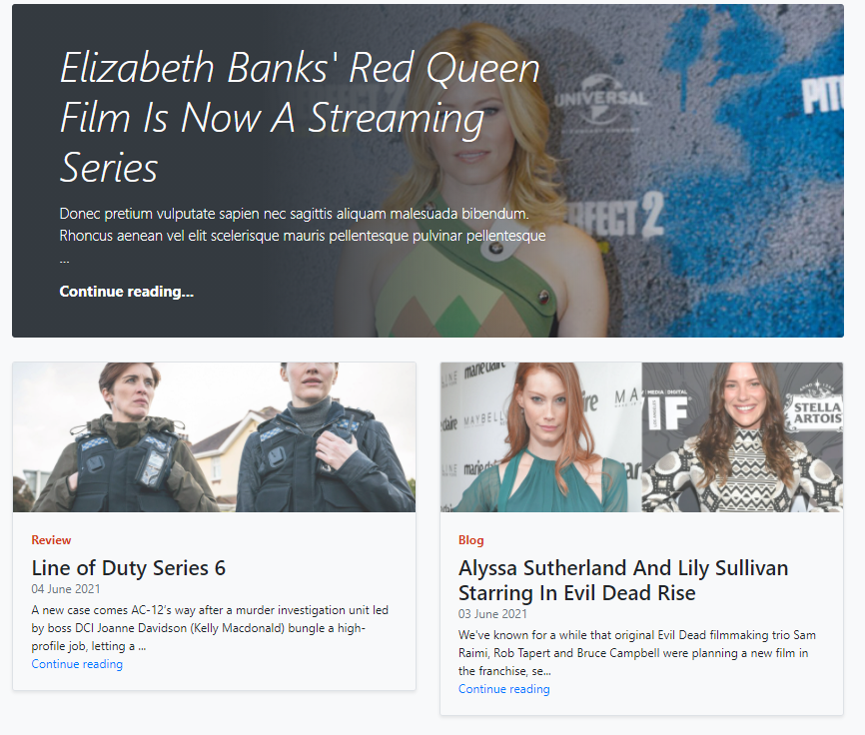
     2. 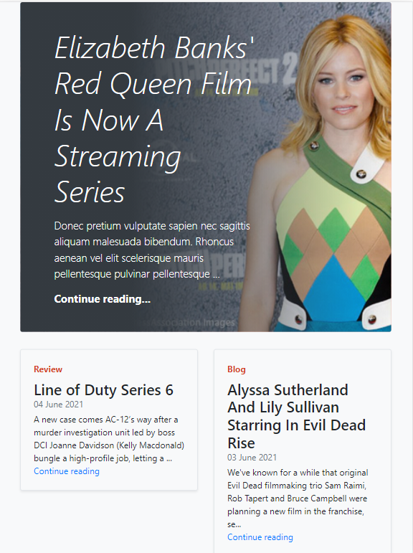
     3. 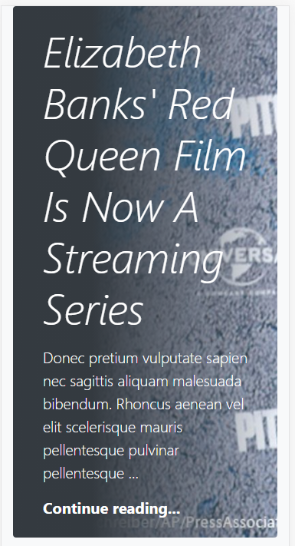 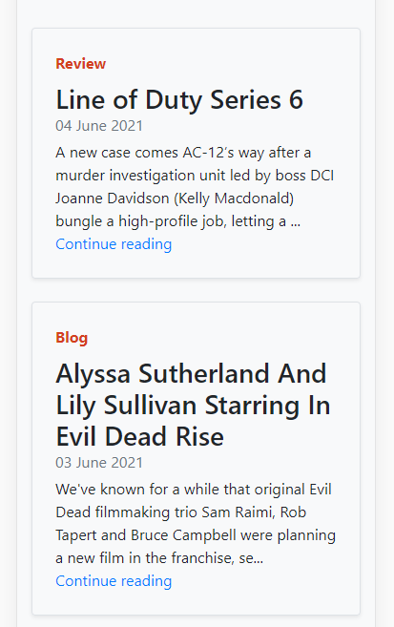
  2. Review Archive
     1. 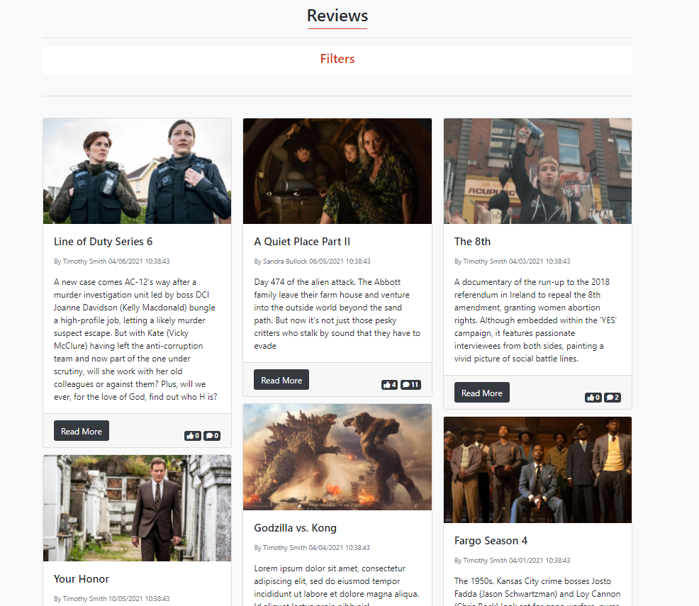
     2. 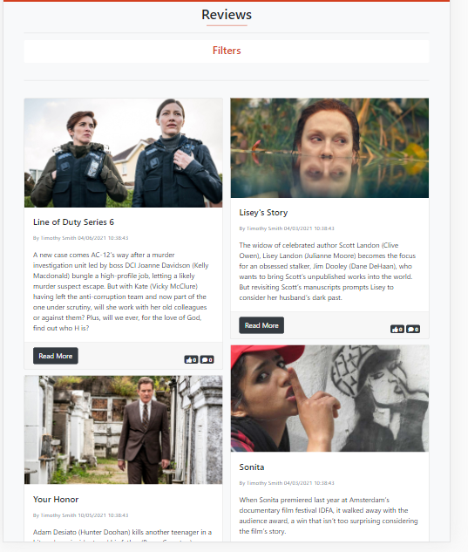
     3. 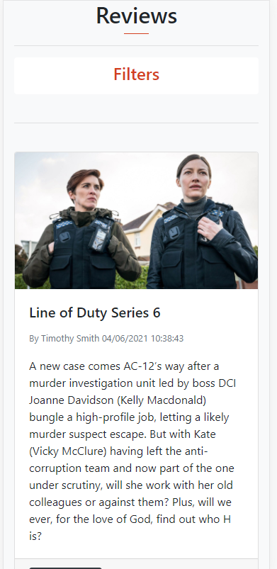
  3. Blog Archive
     1. 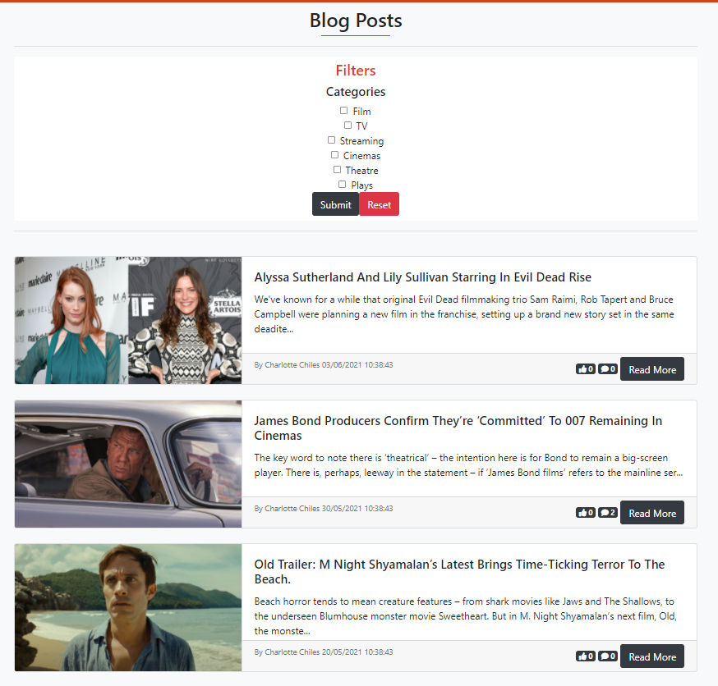
     2. 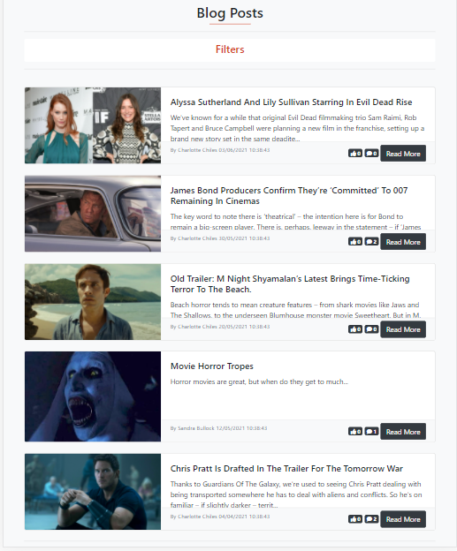
     3. 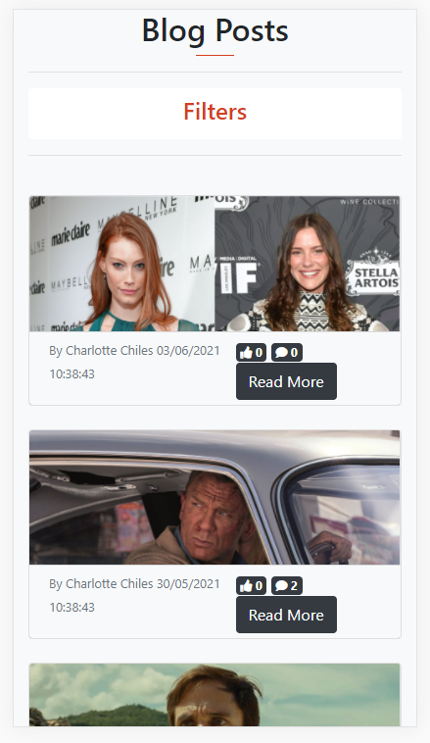
  4. New Archive
     1. 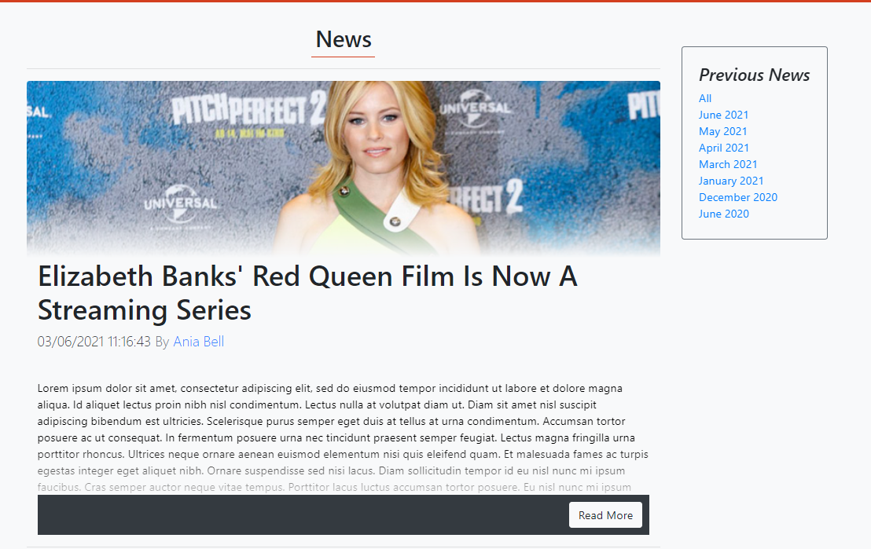
     2. 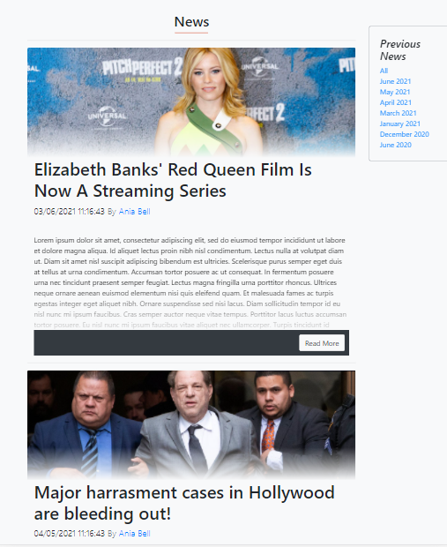
     3. 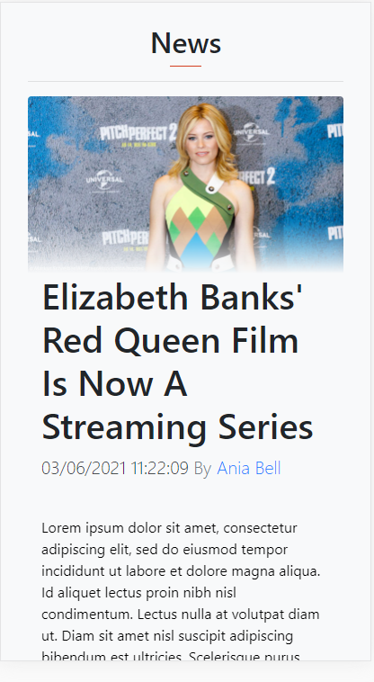
  5. Login/Register
     1. 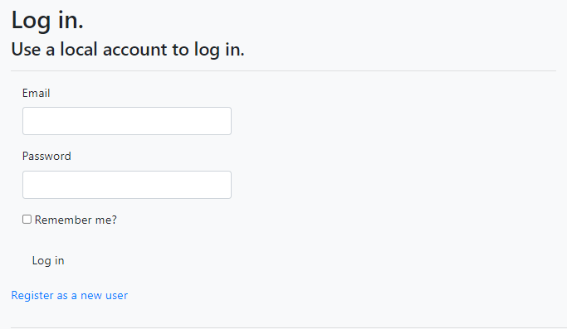  
        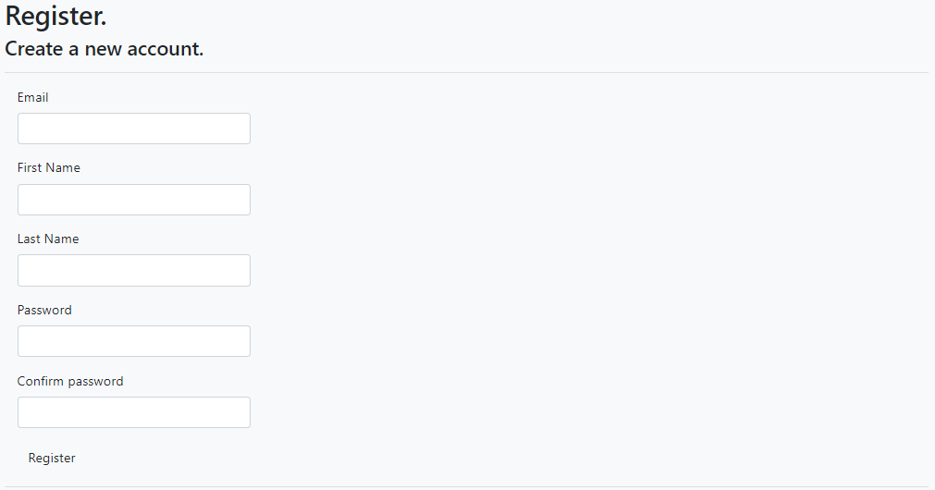
     2. 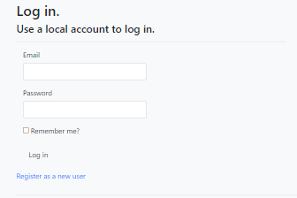  
        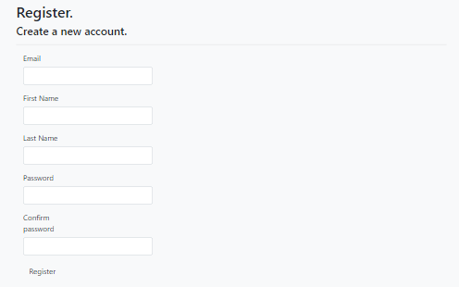
     3. 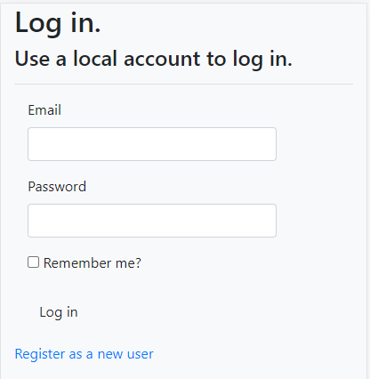  
        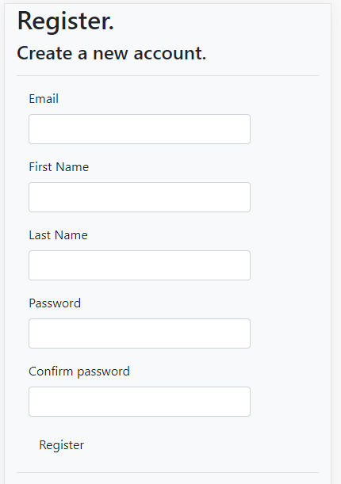
  6. NAVBAR
     1. 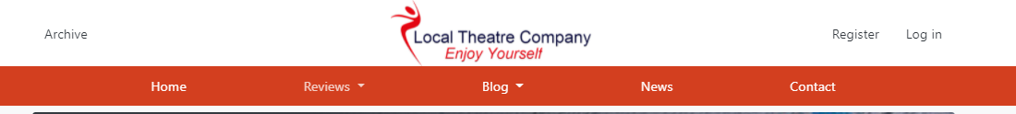
     2. 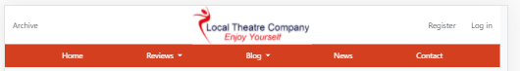
     3. 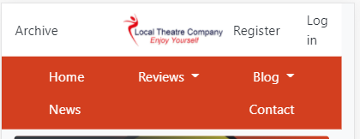

## 2) **View Dashboard**

2.1) Load dashboard

2.1.1)  
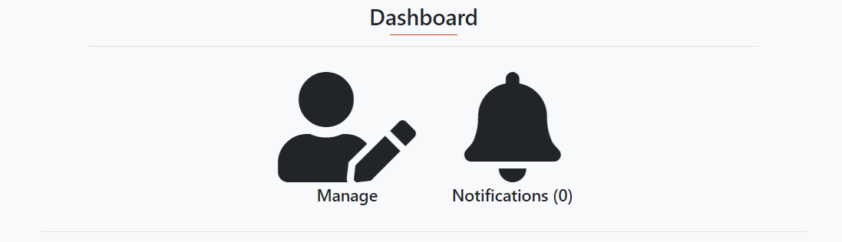

2.1.2)

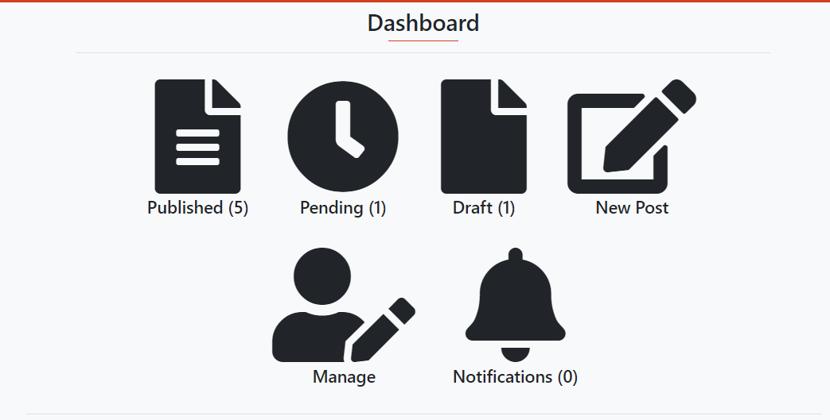

2.1.3)  
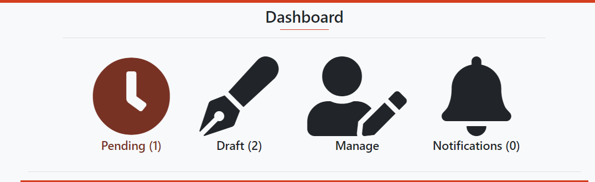

2.1.4)  
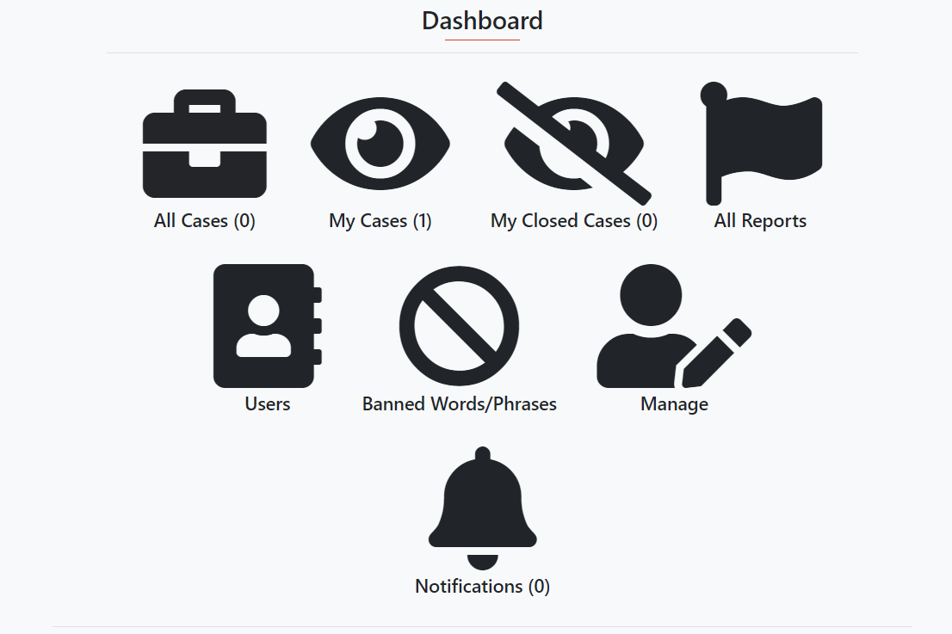

2.1.5)

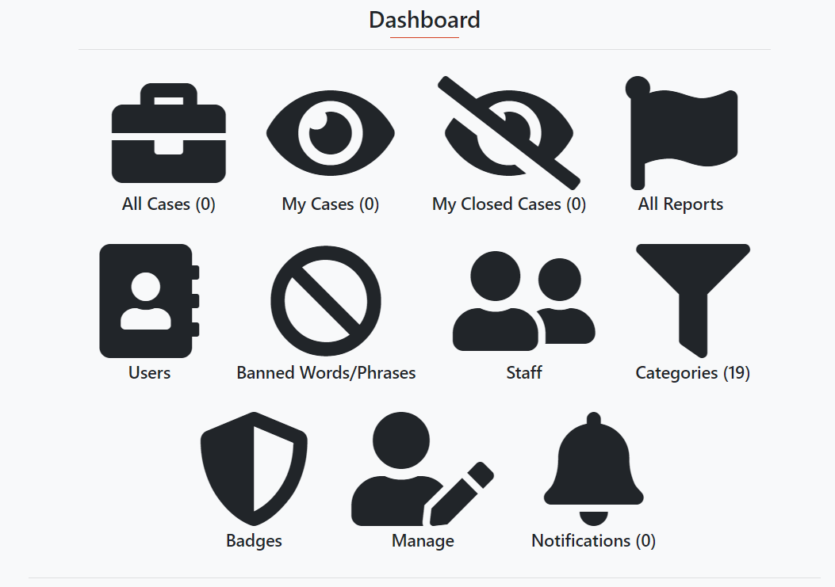

2.1.6)

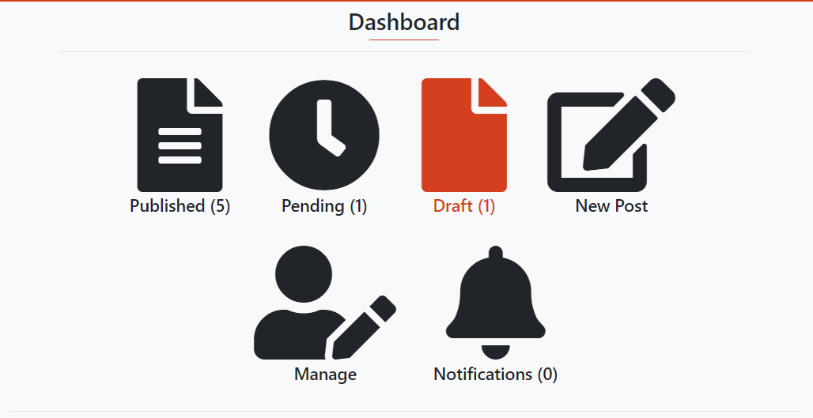

2.1.7)

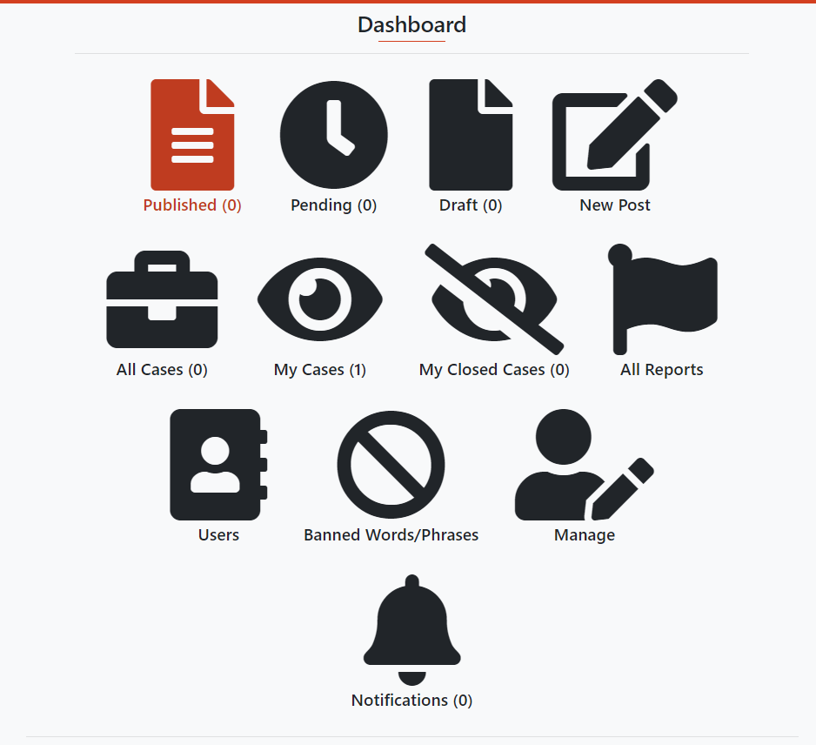

2.1.8)

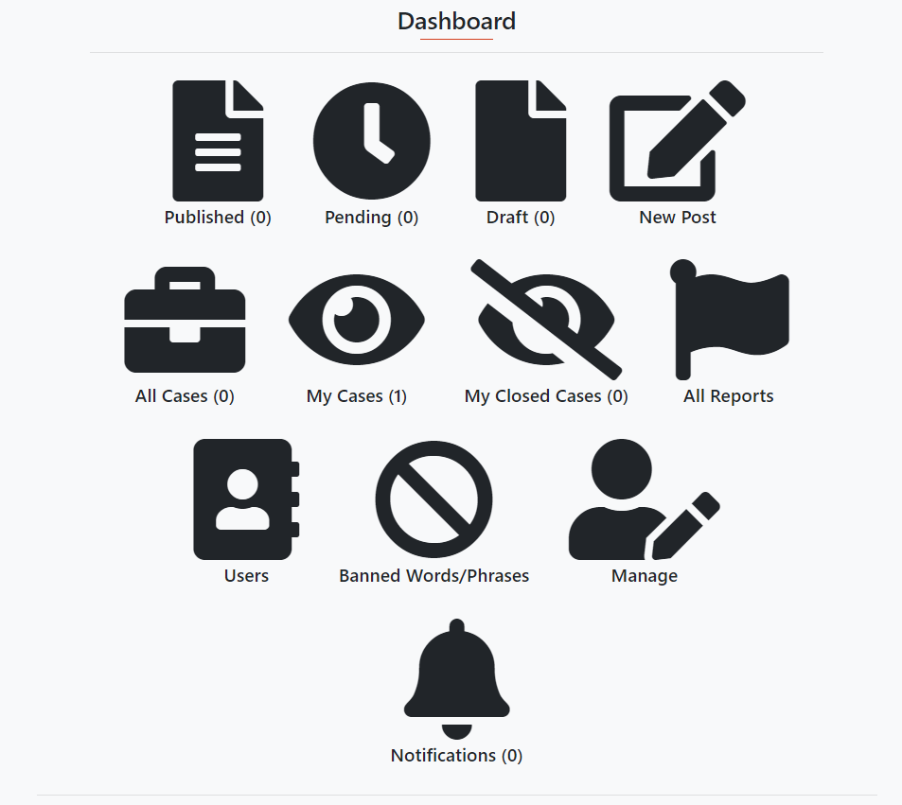

2.2) Load dashboard on different devices

2.2.1)



2.2.2)

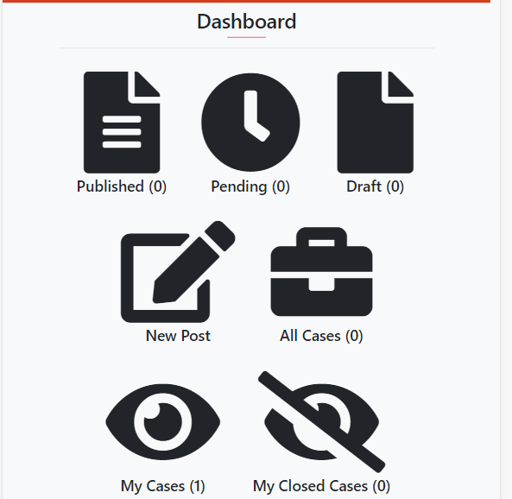

2.2.3)

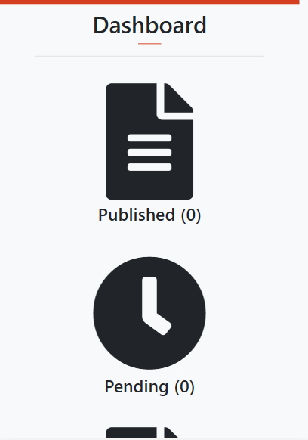

2.3) Access Profile

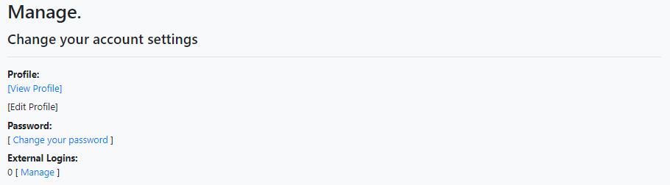

2.4) Notifications Page

2.4.1)

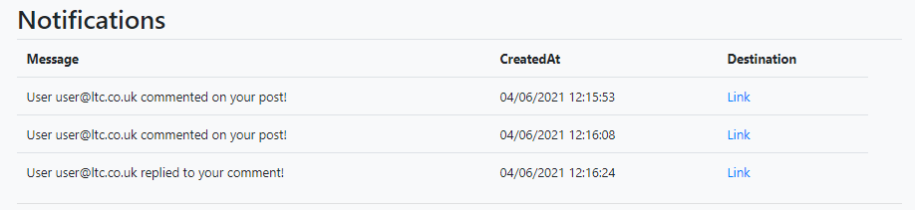

2.5) Published Posts

2.5.2)

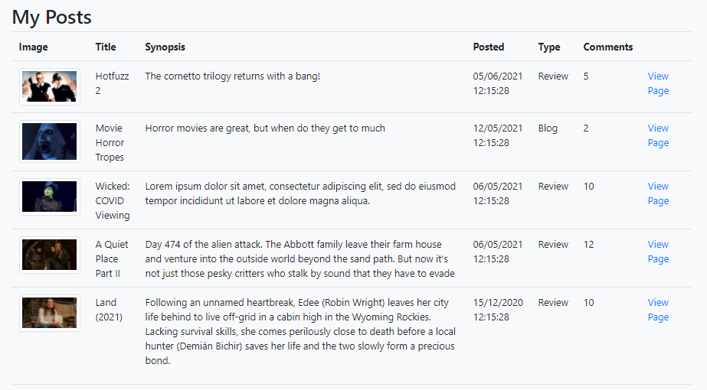

2.6) Pending Post Page

2.6.2)

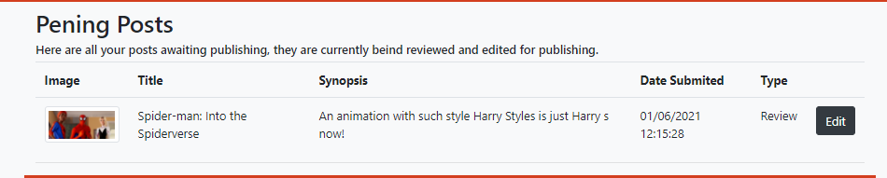

2.6.5)

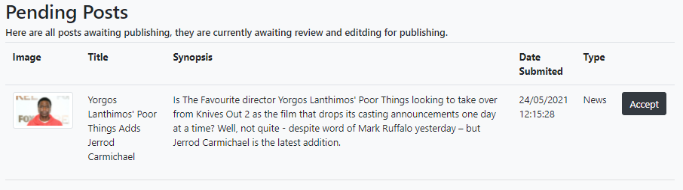

2.7) Draft Posts

2.7.2)

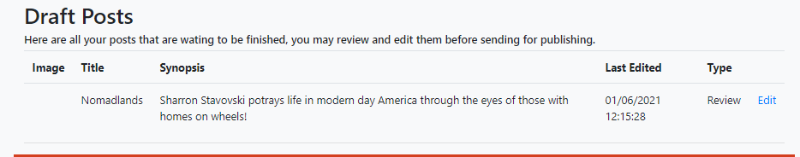

2.7.5)

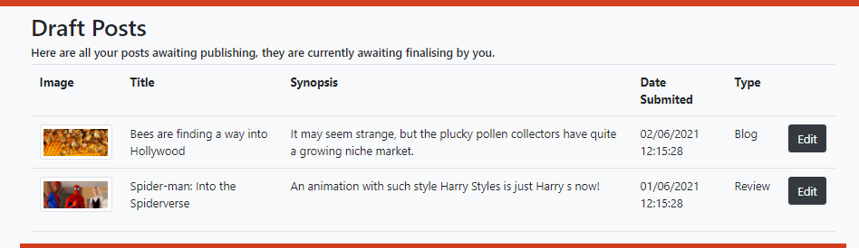

2.8) Create new posts

2.8.1) Review

2.8.1.2)

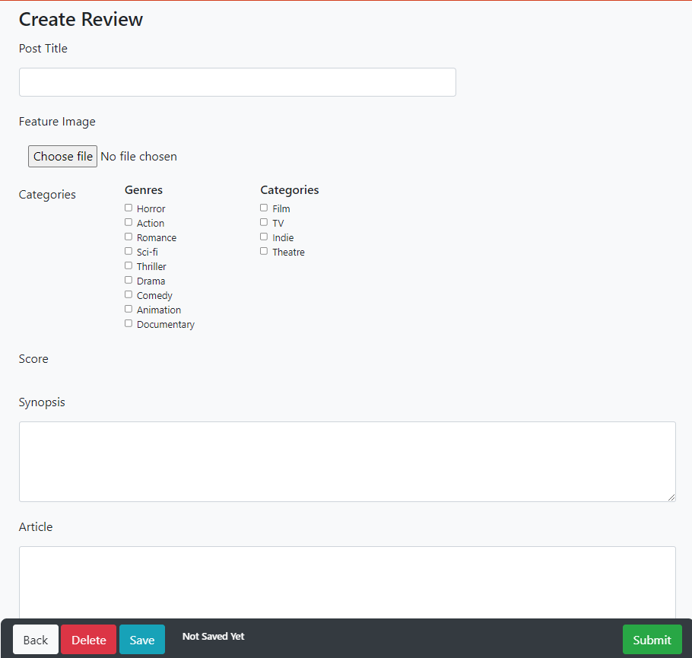

2.8.2) Blog

2.8.2.1)

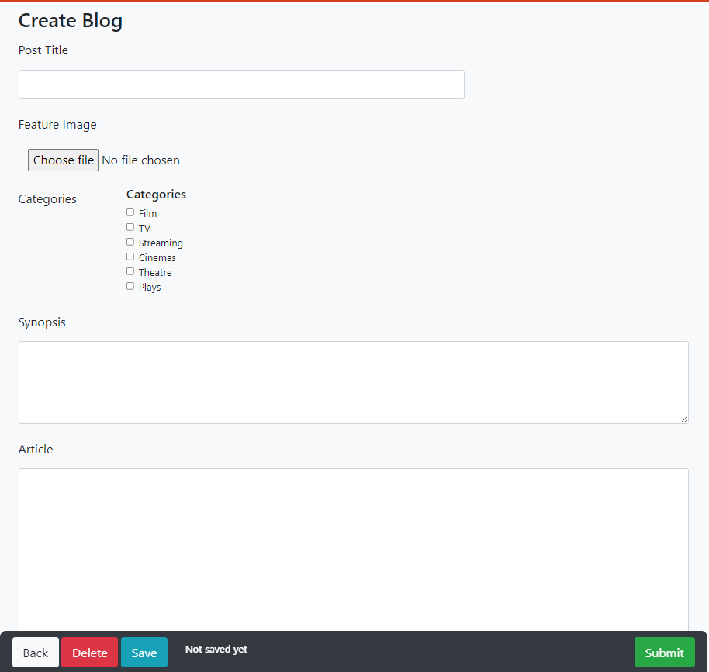

2.8.3) News

2.8.3.2)

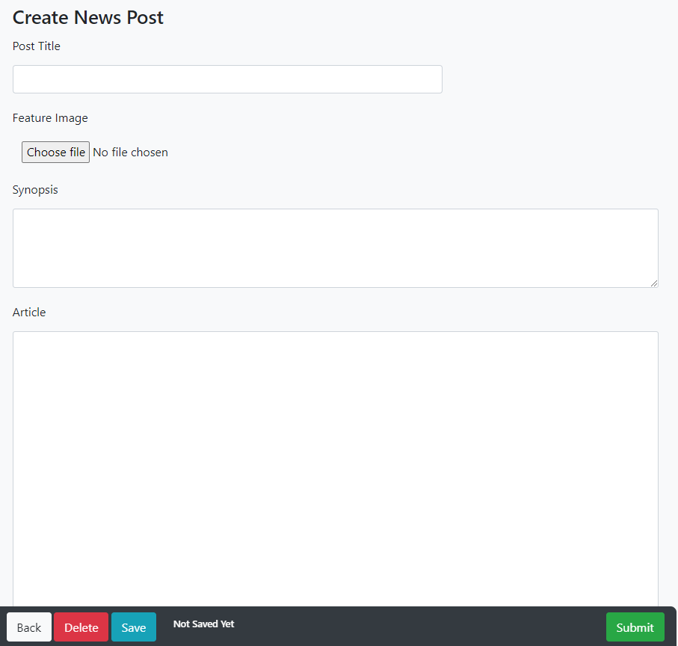

2.9) All Cases

2.9.4)

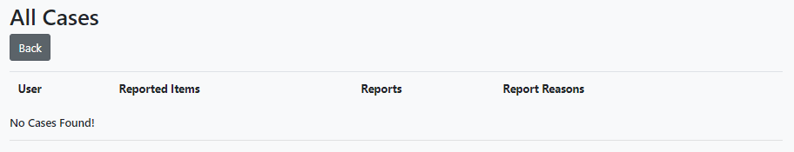

2.9.5)



2.10) My Cases

2.10.4)

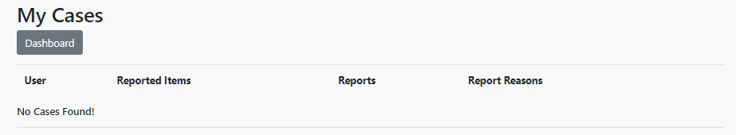

2.10.5)

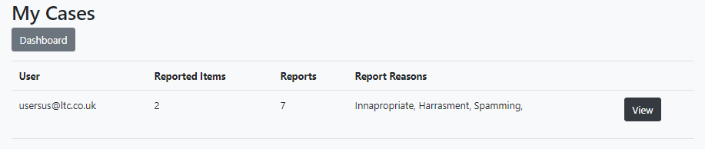

2.11) My Closed Cases

2.11.4)

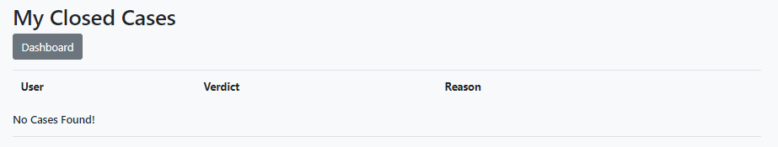

2.11.5)



2.12) All Reports

2.12.4)

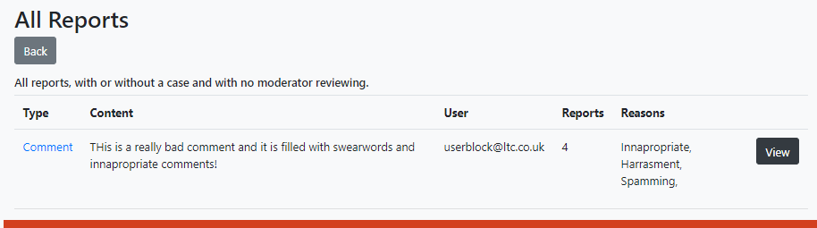

2.12.5)



2.13) All Users

2.13.4)

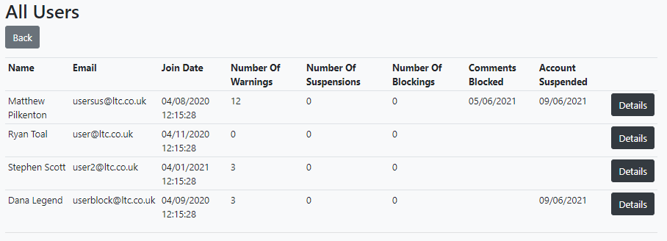

2.13.5)



2.14) All Staff

2.14.5)

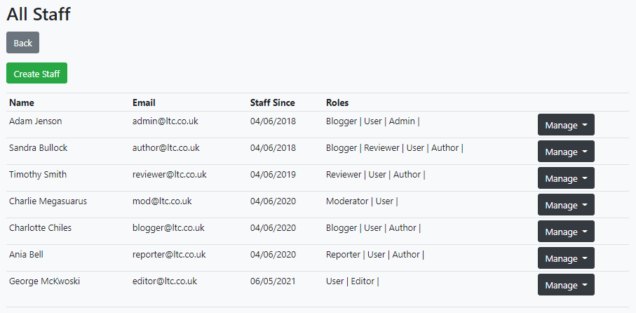

2.15) All Categories

2.15.5)

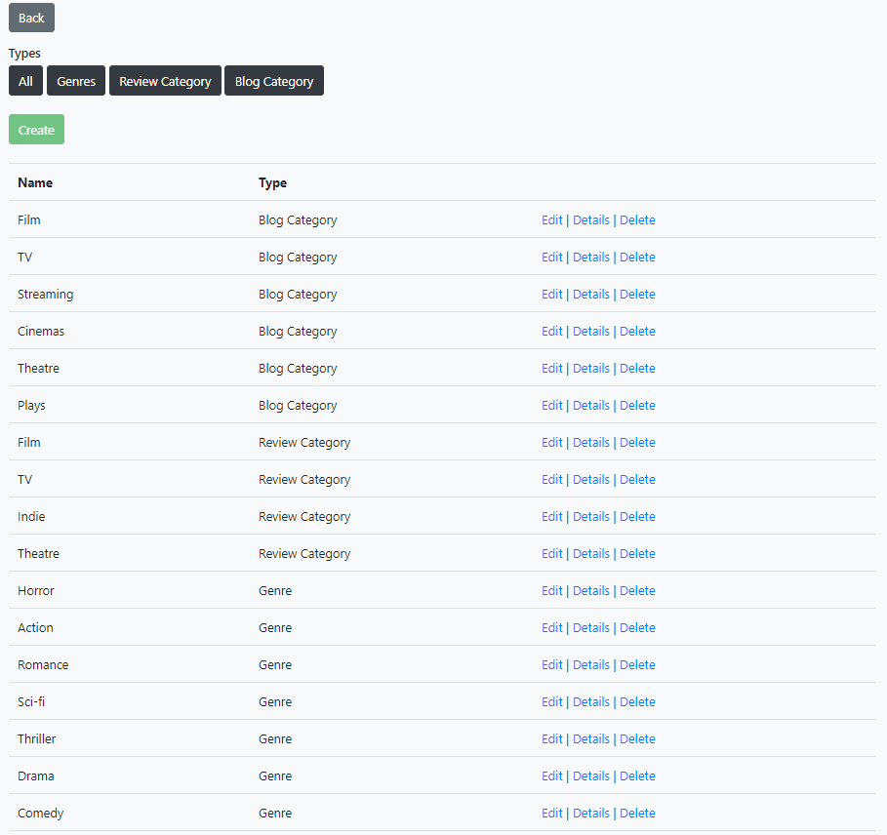

2.16) All Badges

2.16.5)

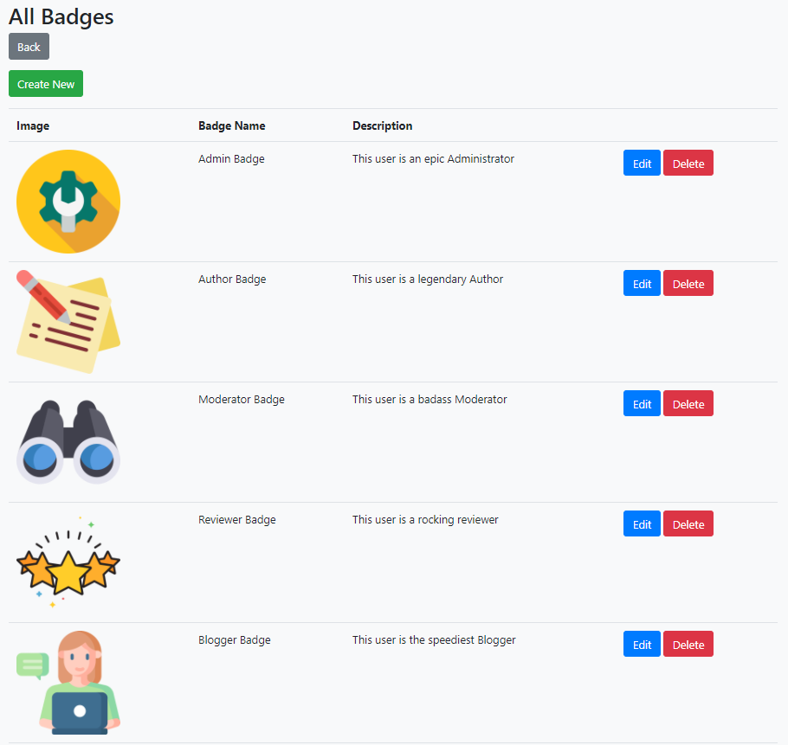

2.17) All Banned Content

2.17.5)

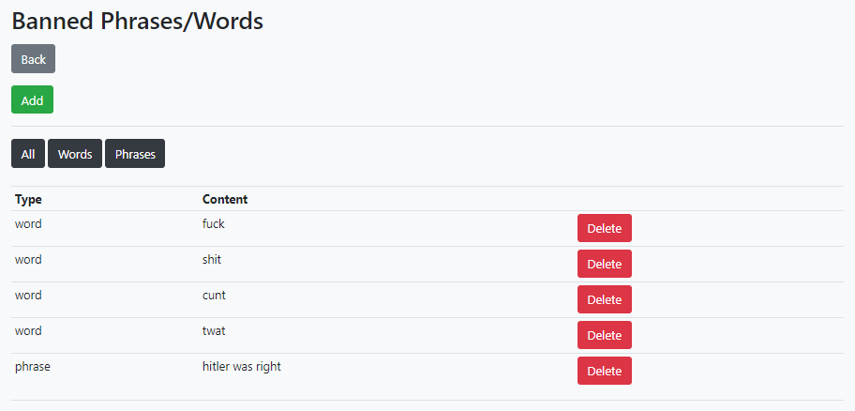

## 3) **Post Archives**

3.1) Reviews

3.1.1)

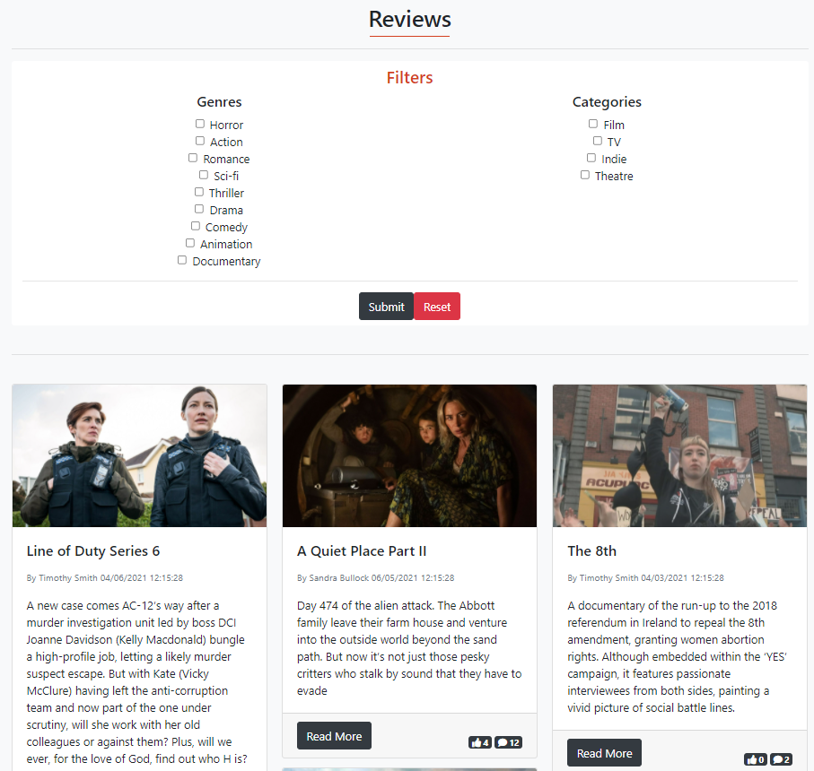

3.1.2)

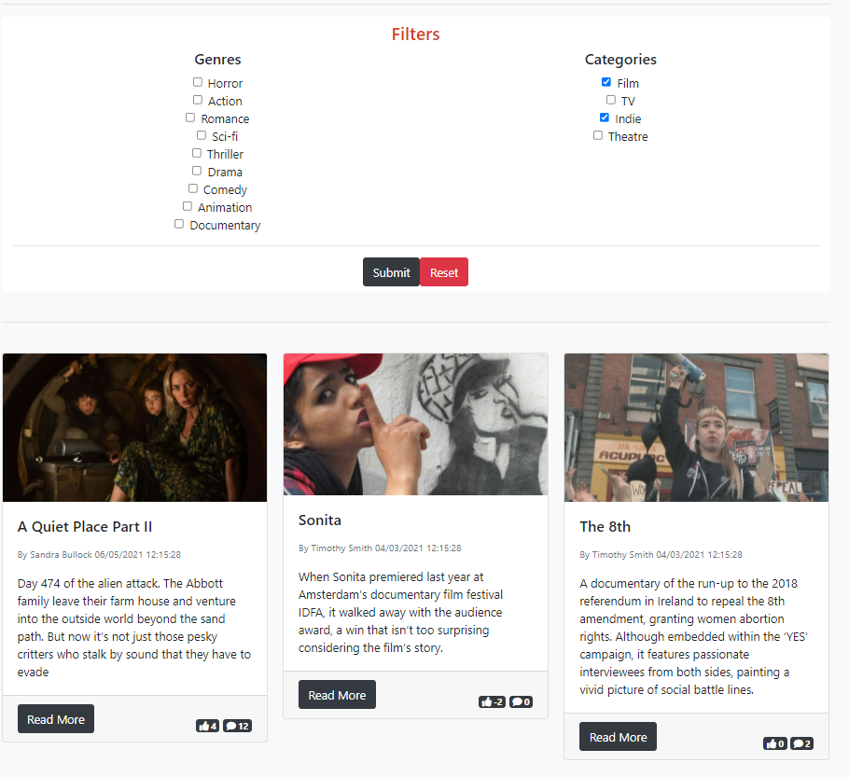

3.1.3)

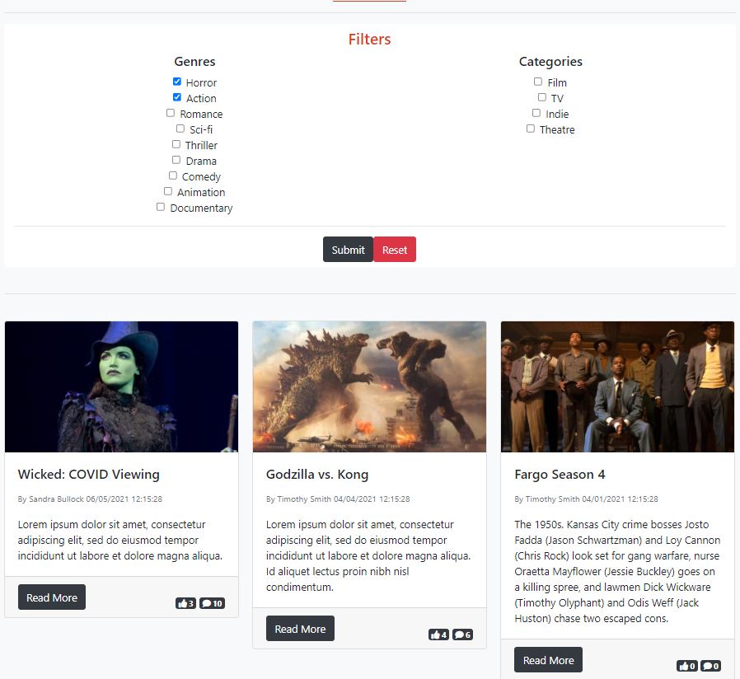

3.1.4)

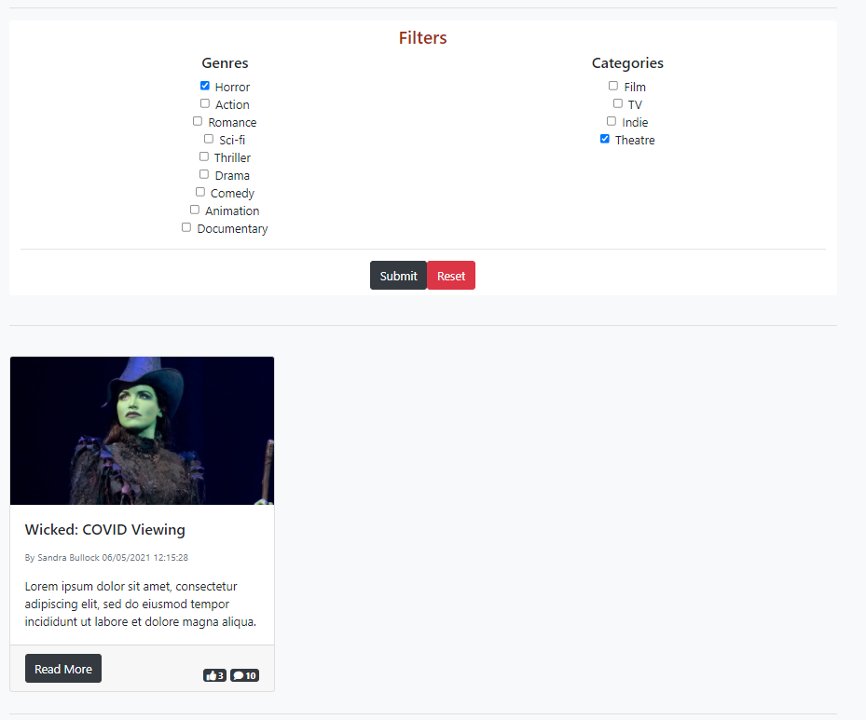

3.1.5)

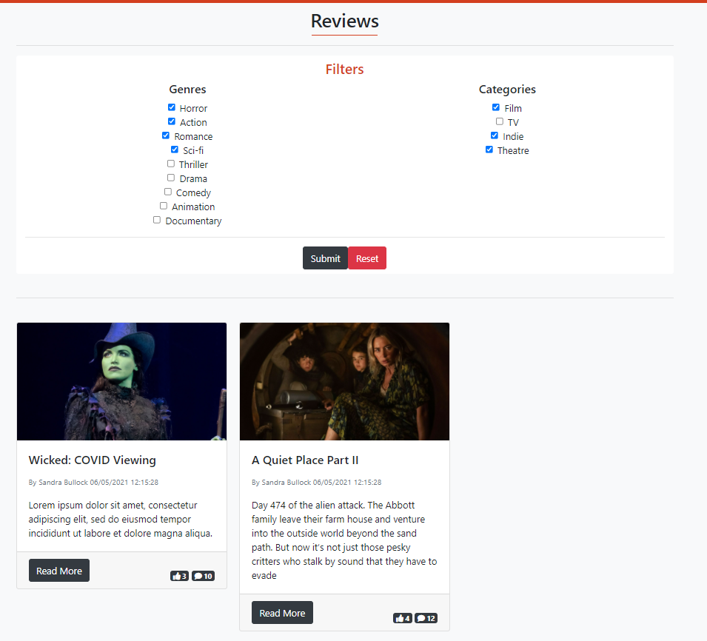

3.2) Blogs

3.2.1)

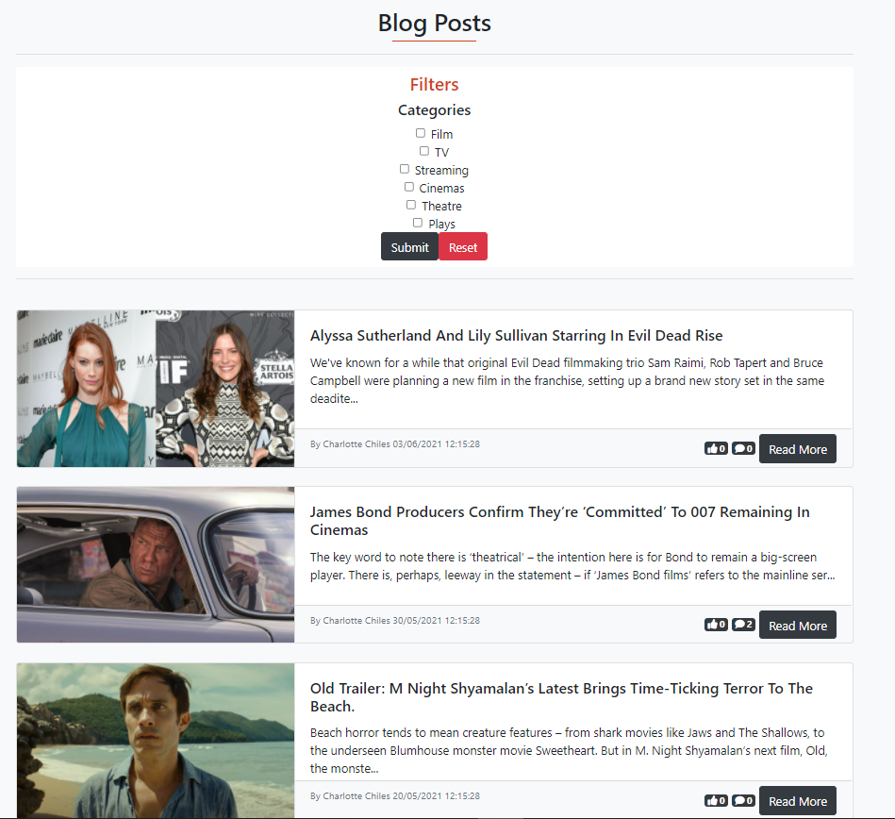

3.2.2)

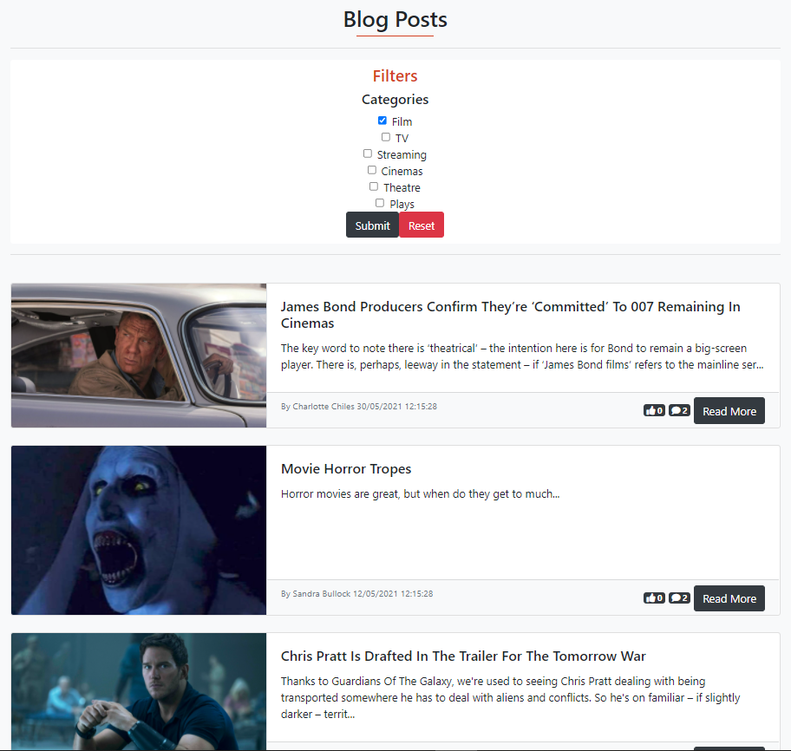

3.2.3)

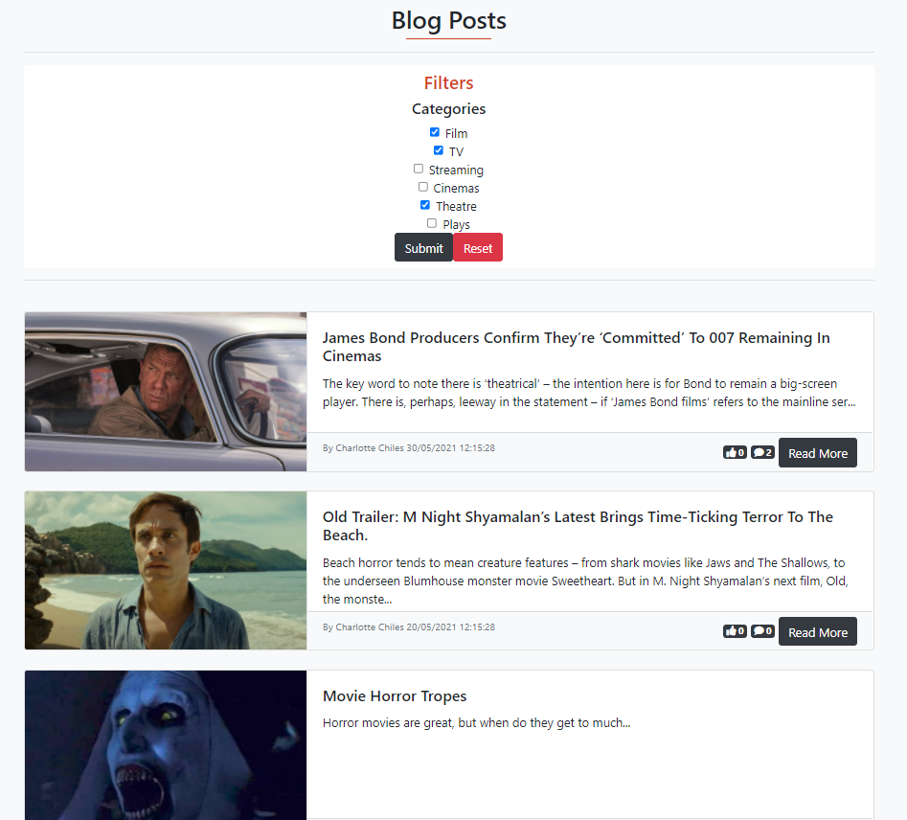

3.2.4)

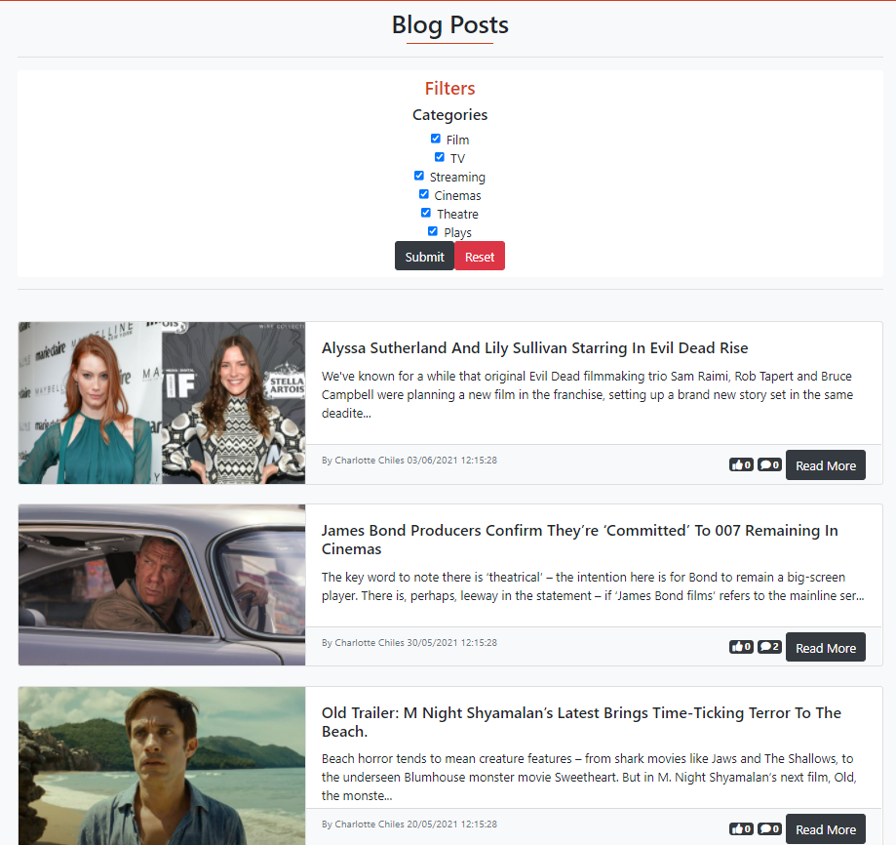

3.3) News

3.3.1)

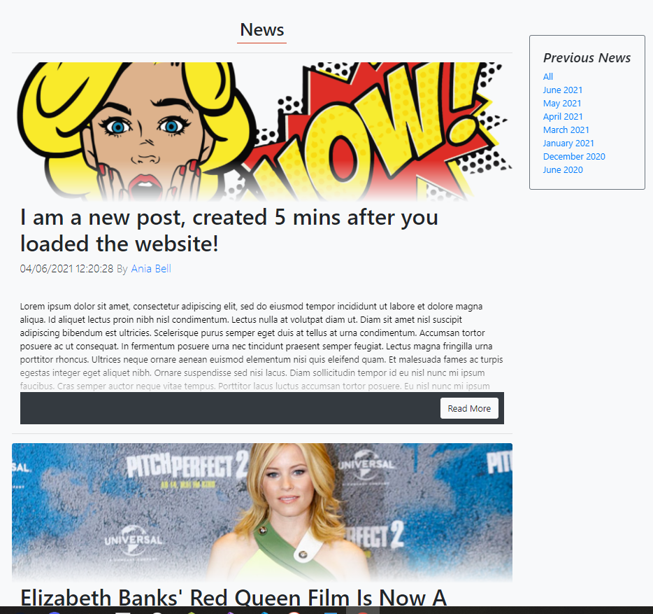

3.3.2)

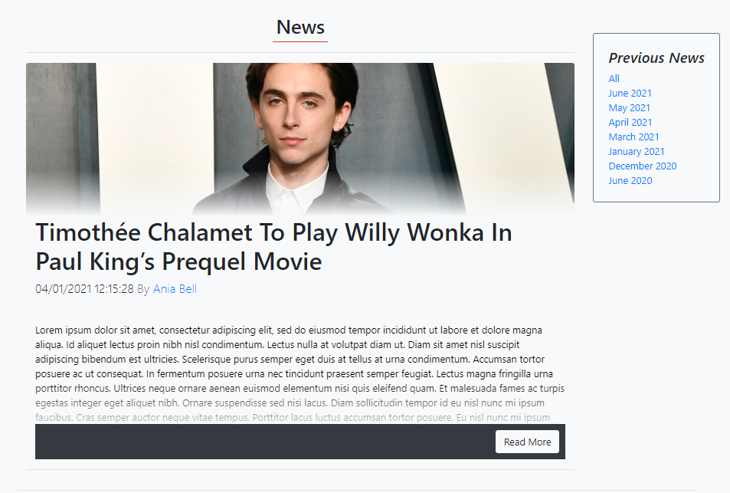

3.3.3)

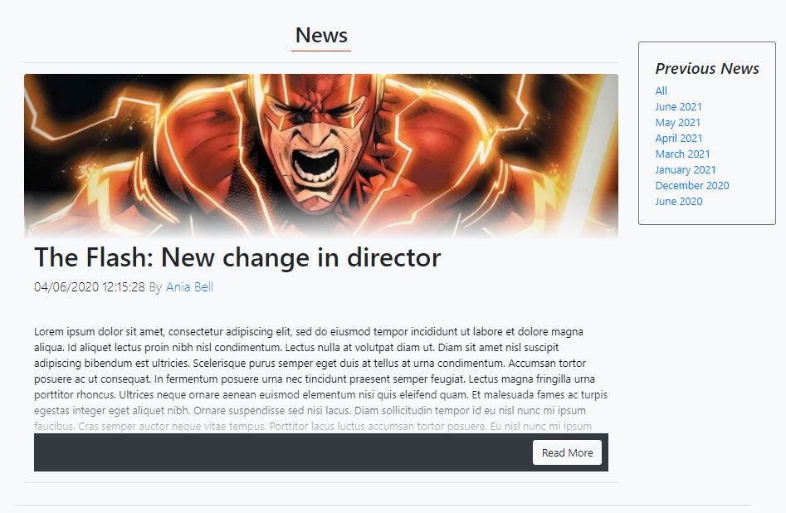

## 4) **Commenting**

4.1) Commenting on a post

4.1.1)

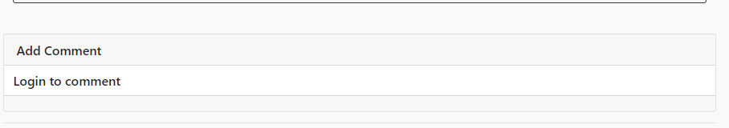

4.1.2) 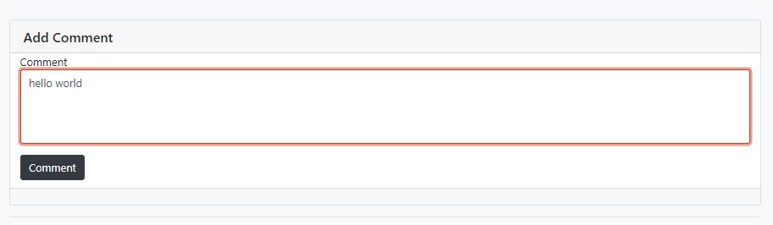

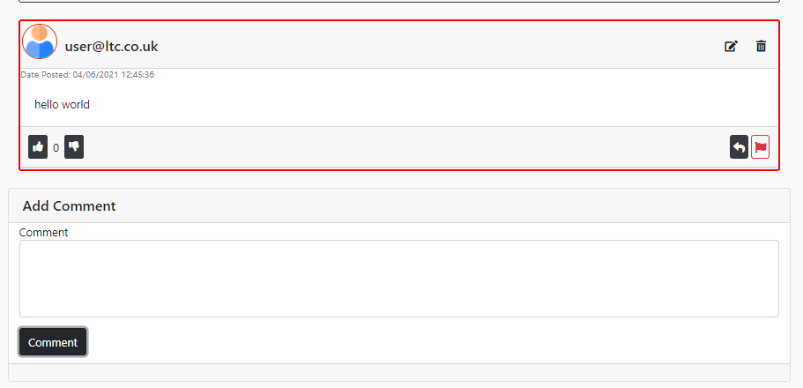

4.1.3)

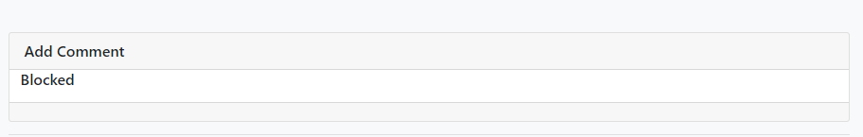

4.1.4)

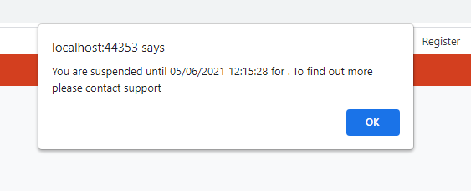

4.1.5)

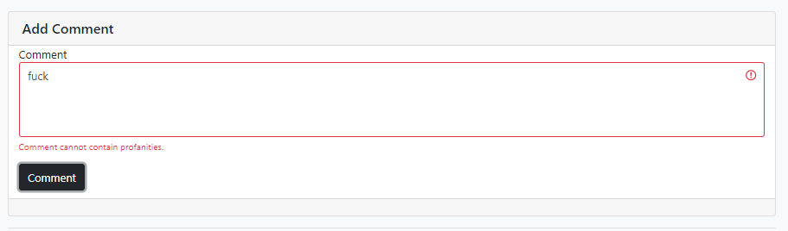

4.2) Replying

4.2.1)

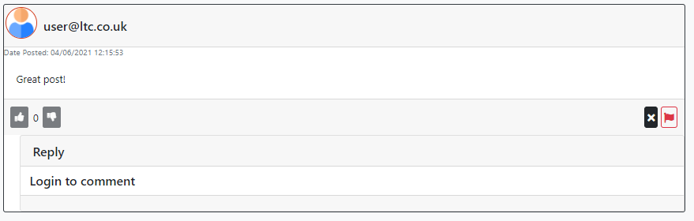

4.2.2)

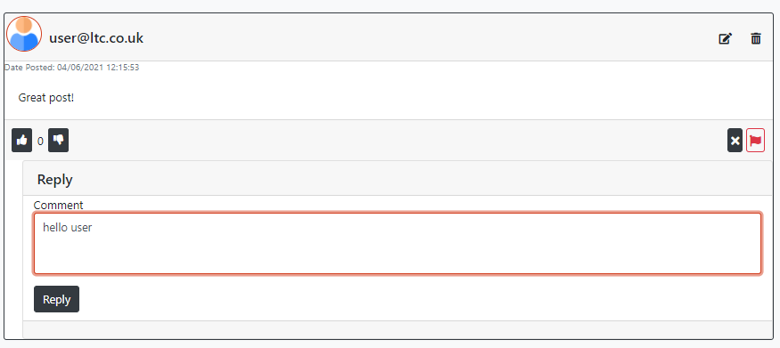

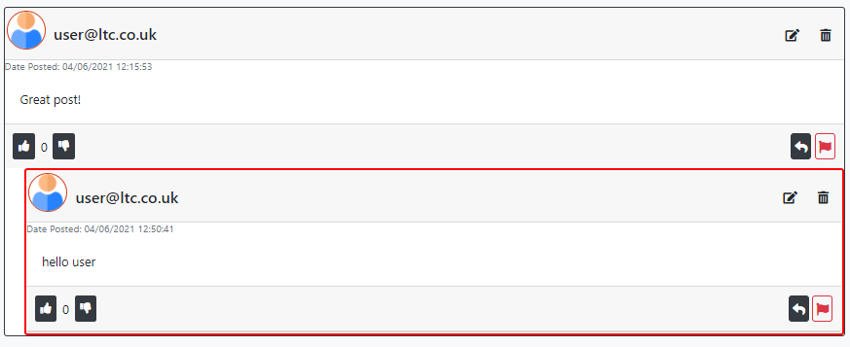

4.2.3)



4.2.4)



4.2.5)

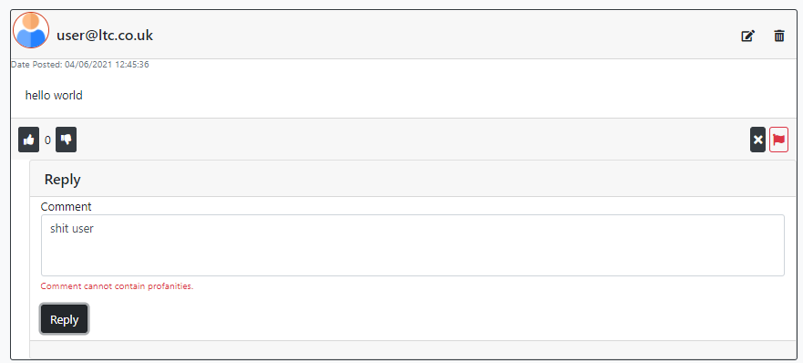

4.3) Editing a comment

4.3.1)

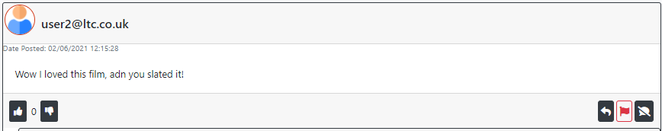

4.3.2)

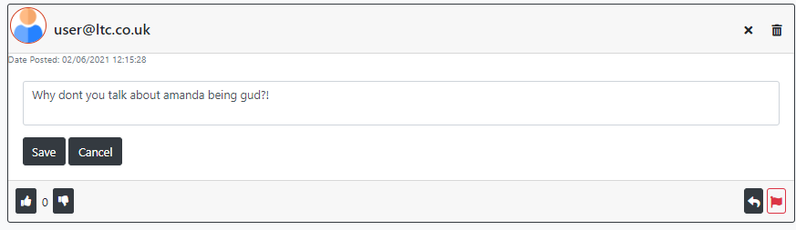

4.3.3)

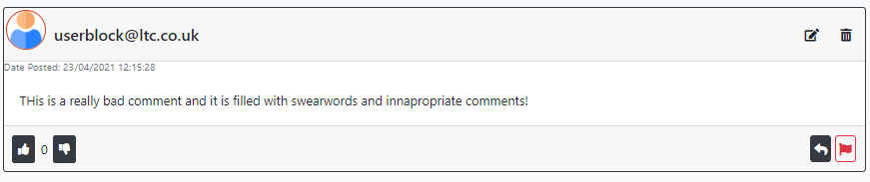

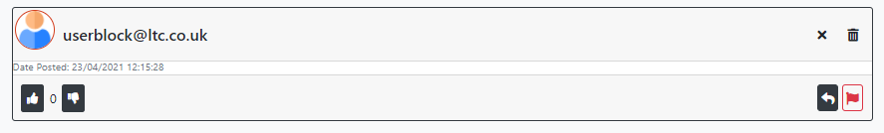

4.3.4)



4.3.5)

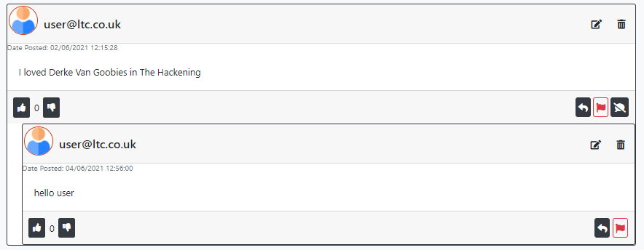

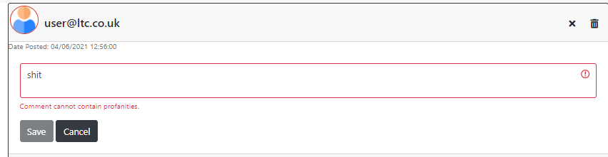

4.4) Deleting a comment

4.4.1)

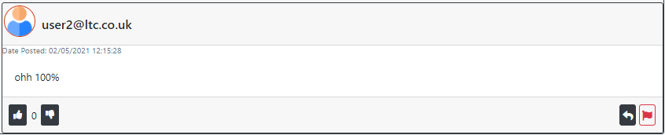

4.4.2)

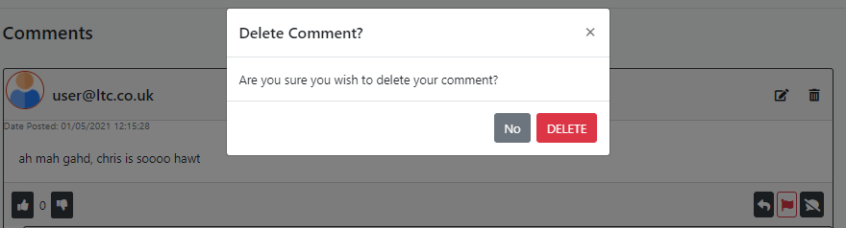

4.4.3)

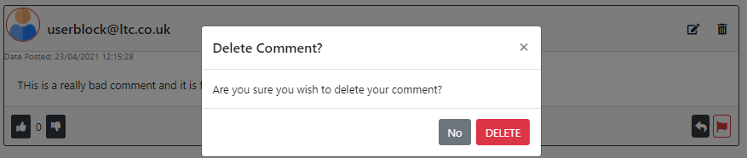

4.4.4)

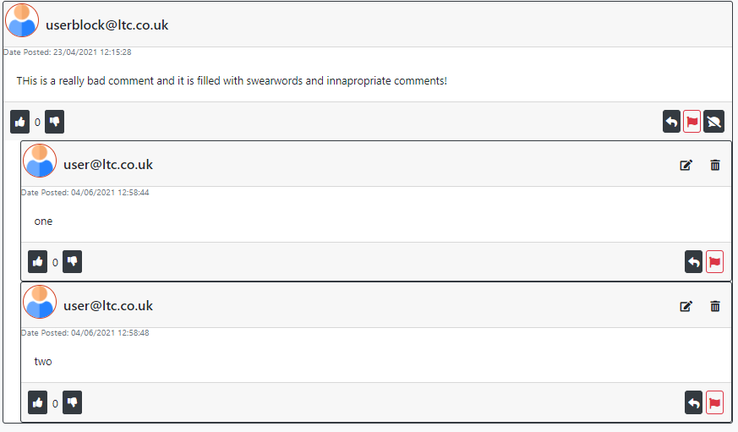

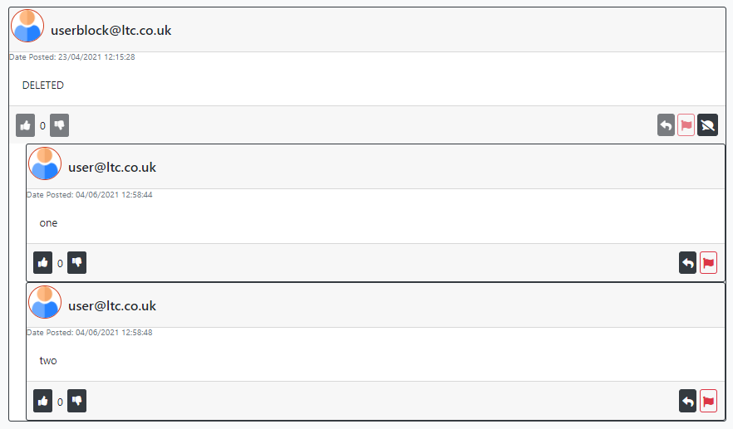

4.4.5)

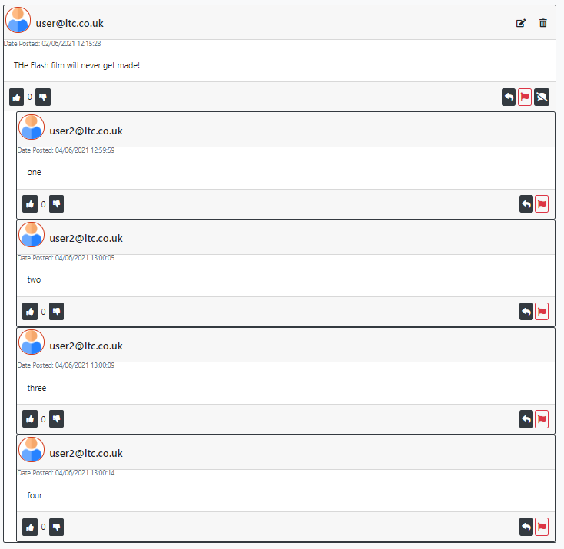

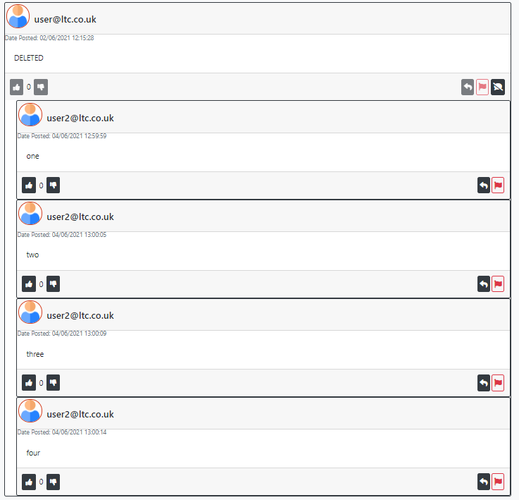

## 6) **User Controls**

6.4) Report a comment

6.4.1)

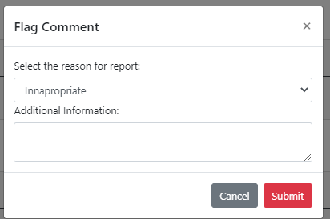

6.4.3)

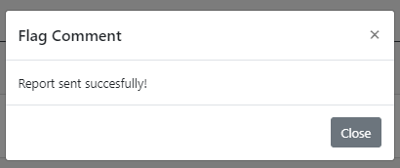

6.4.4)

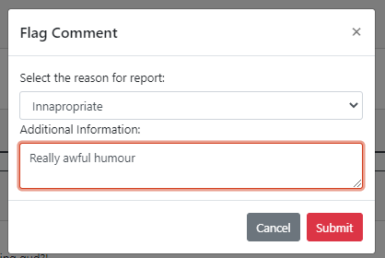



6.6) Report a post

6.6.1)

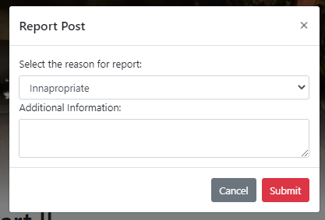

6.6.3)

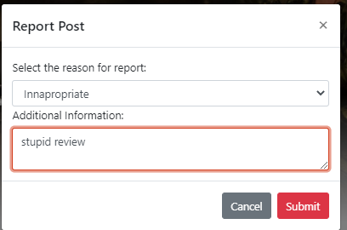

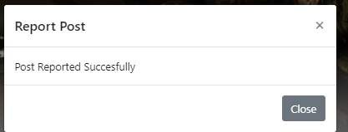

## 7) Author Controls

7.2.2.1)

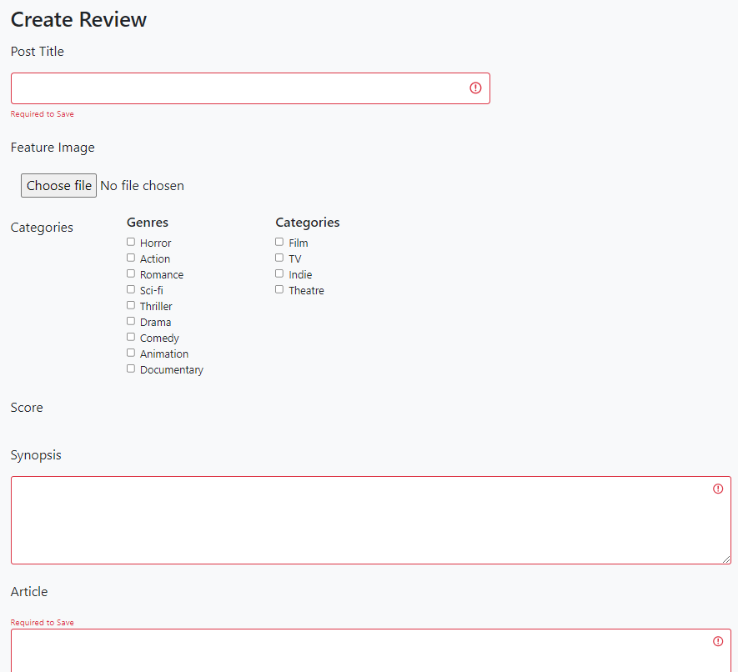

7.2.2.3)

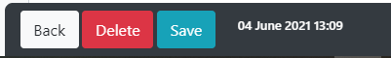

7.2.3.1)

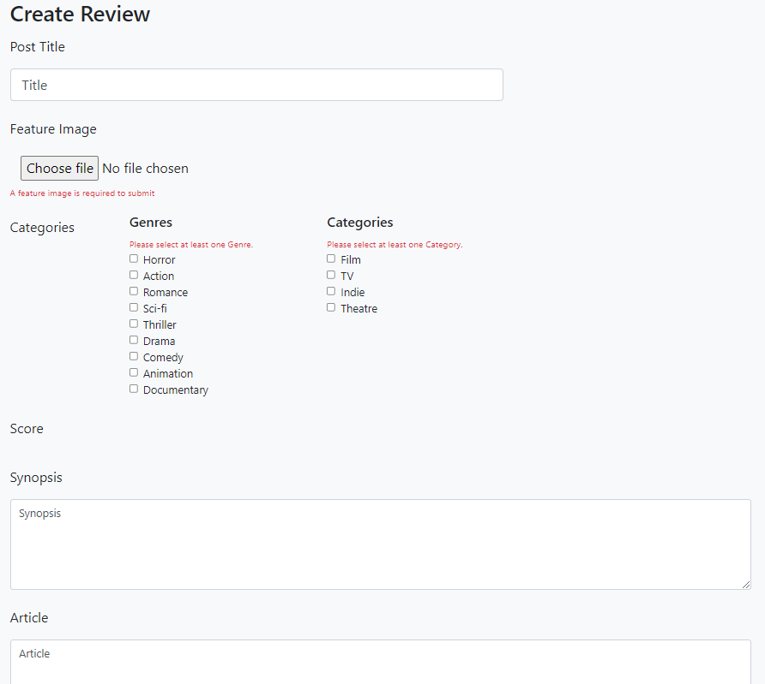



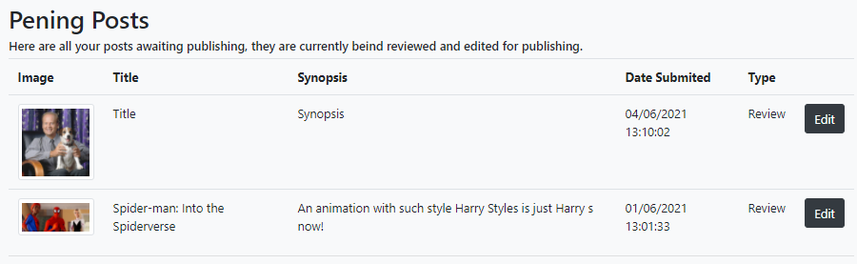

## 8) Moderator Controls

8.1)Reported Item

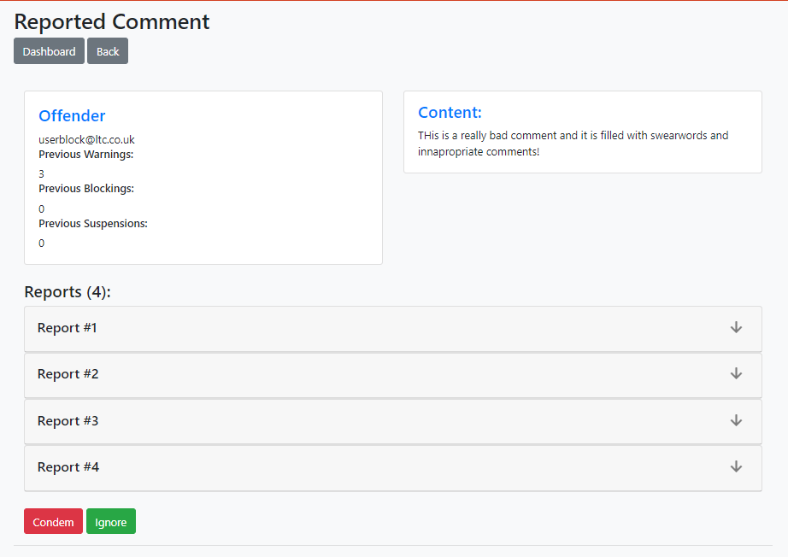

8.1.1) Forgive

8.1.1.1)

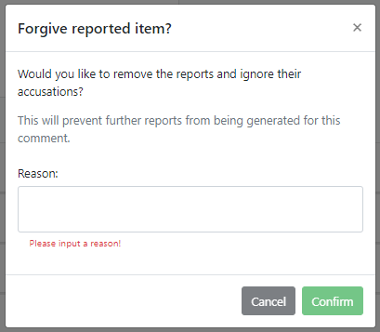

8.1.2) Condemn

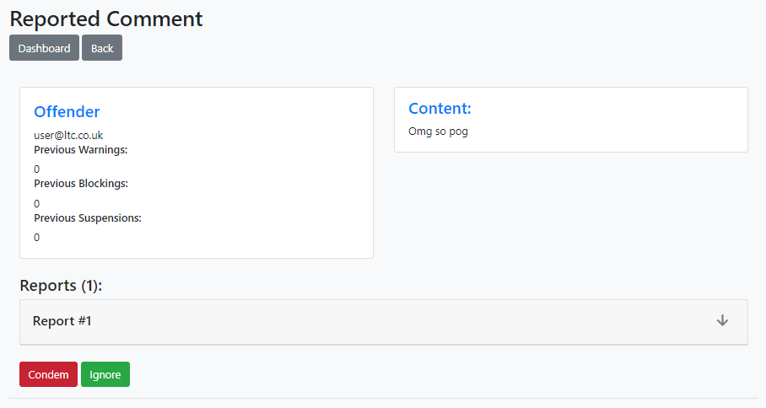

8.2.2.1)

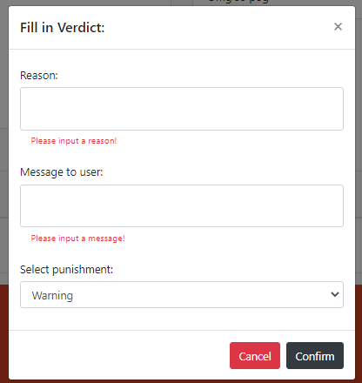

8.2.2.2)

8.

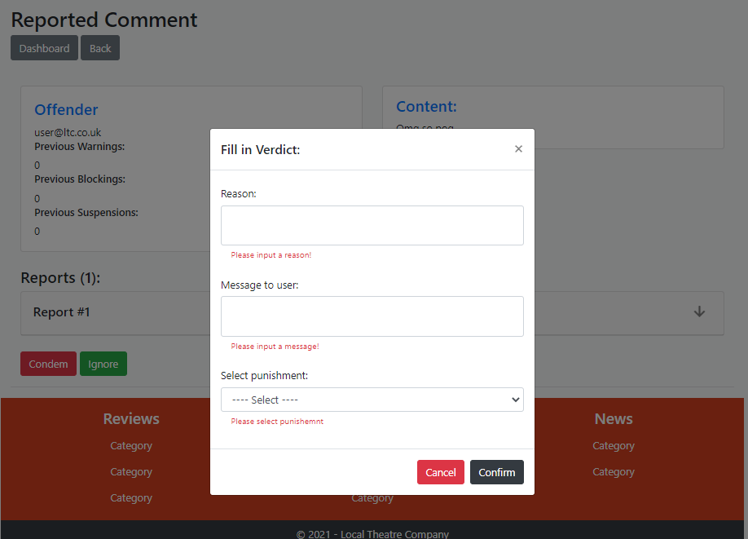

8.1.2.3)

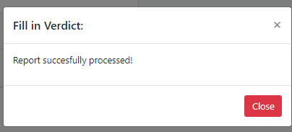

8.3) View case

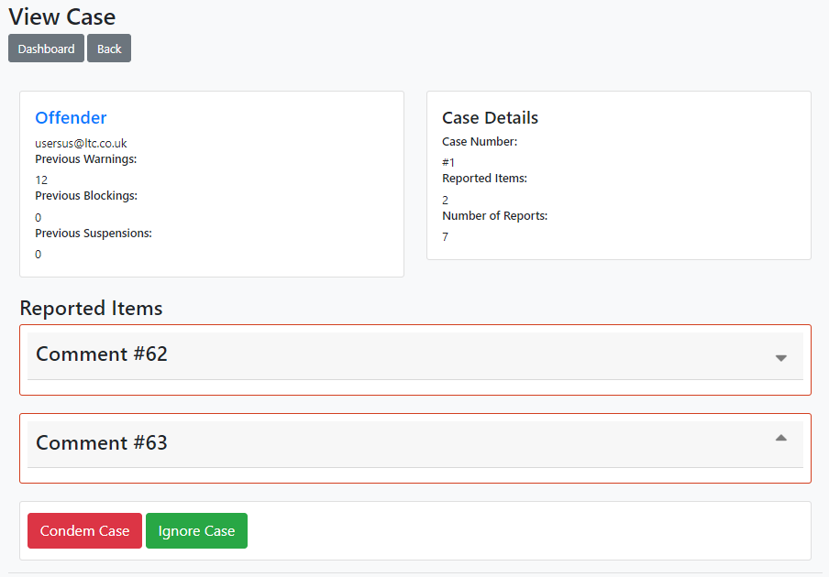 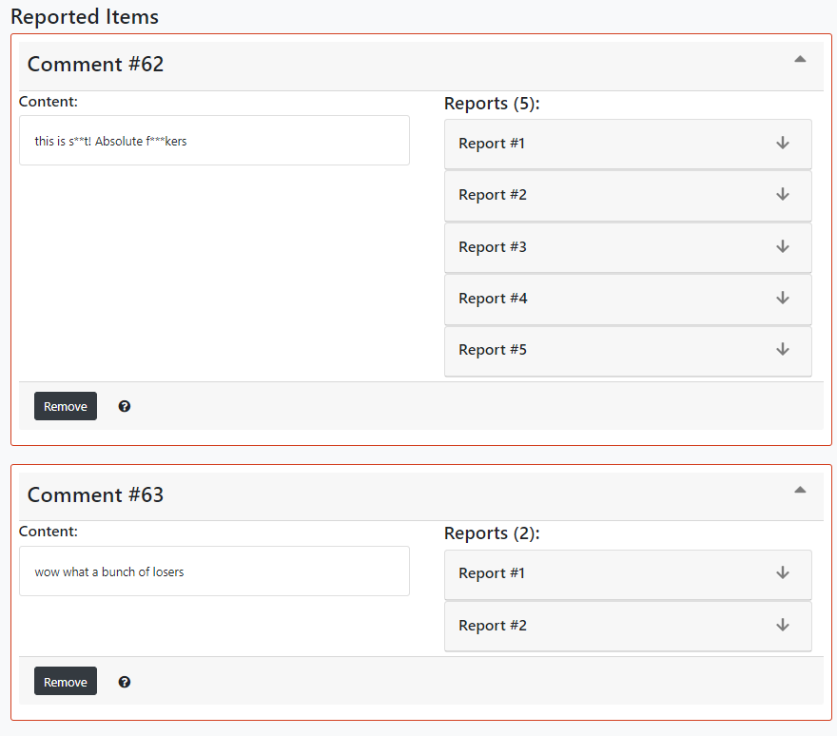

8.3.1) Forgive individual report

8.3.1.1)

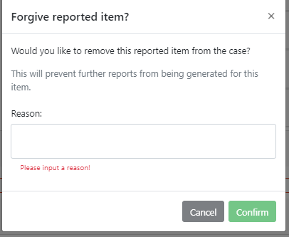

8.3.1.2)

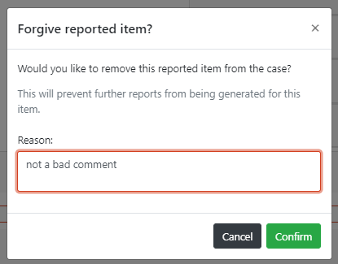 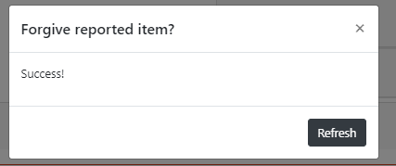

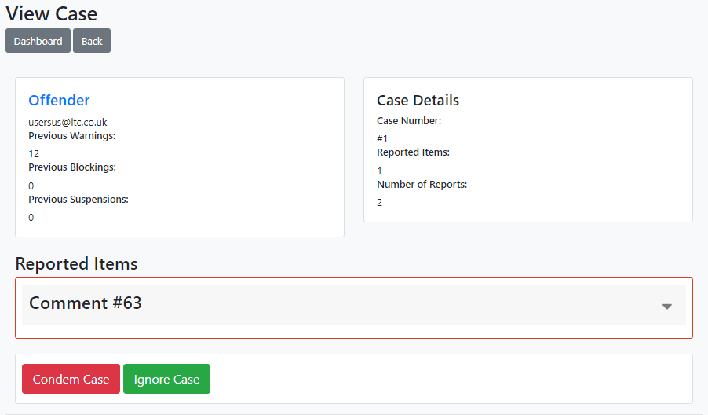

8.3.2) Forgive whole case

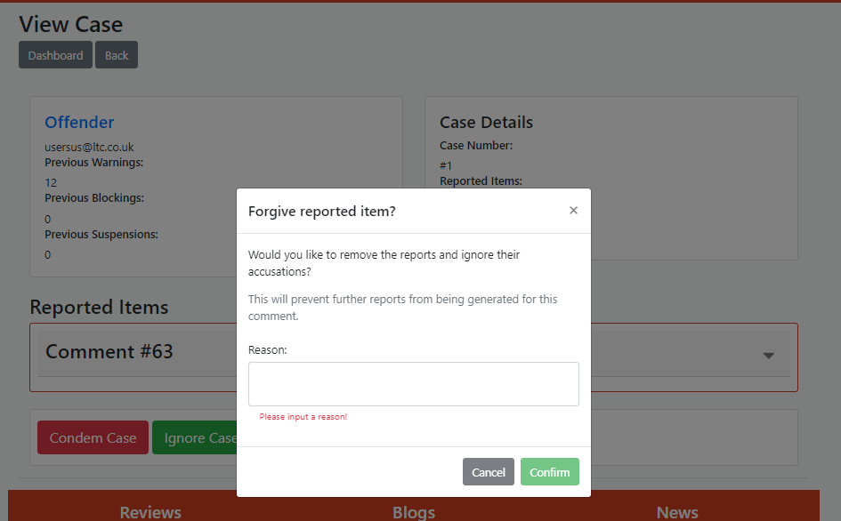

8.3.3) Condemn Case

8.3.3.1)

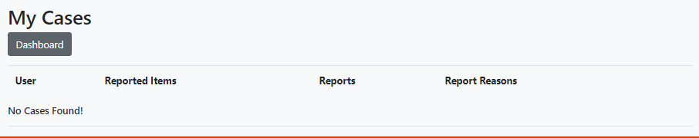

8.3.3.2)

